MINI PROJECT

(SESSION-2019-2020)

Report



**Institute of Engineering & Technology**

**Team Members**

**ABHISHEK GUPTA**

**(181500017)**

**ANUSHKA MAHESHWARI**

**(181500124)**

**AKANSHA GUPTA**

**(181500053)**

## Supervised By

**MR. ANAND GUPTA**

**TECHNICAL TRAINER**

**Department of Computer Engineering &Websites**

**Department of Computer Engineering and Applications**

**GLA University, Mathura**

**17 km. Stone NH#2, Mathura-Delhi Road, P.O. – Chaumuha,**

**Mathura – 281406**



**Declaration**

I hereby declare that the work which is being presented in the Mini Project **“HELPING HANDS”,** in partial fulfillment of the requirements for Mini project Lab is an authentic record of our own work carried under the supervision of **Mr. Anand Gupta, Technical Trainer.**

**Abhishek Gupta**

**Anushka Maheshwari**

**Akansha Gupta**

**Department of Computer Engineering and Applications**

**GLA University, Mathura**

**17 km. Stone NH#2, Mathura-Delhi Road, P.O. – Chaumuha,**

**Mathura – 281406**



**Certificate**

This is to certify that the project entitled “HELPING HAND” carried out in Mini Project – I Il Lab is a bonafide work done by Abhishek Gupta (181500017), Akansha Gupta(181500053),

Anushka Maheshwari (181500124) and is submitted in partial fulfillment of the requirements for the award of the degree Bachelor of Technology (ComputerScience & Engineering).

**Signature of Supervisor:**

**Name of Supervisor: Mr. Anand Gupta**

**Date:05/04/2020**

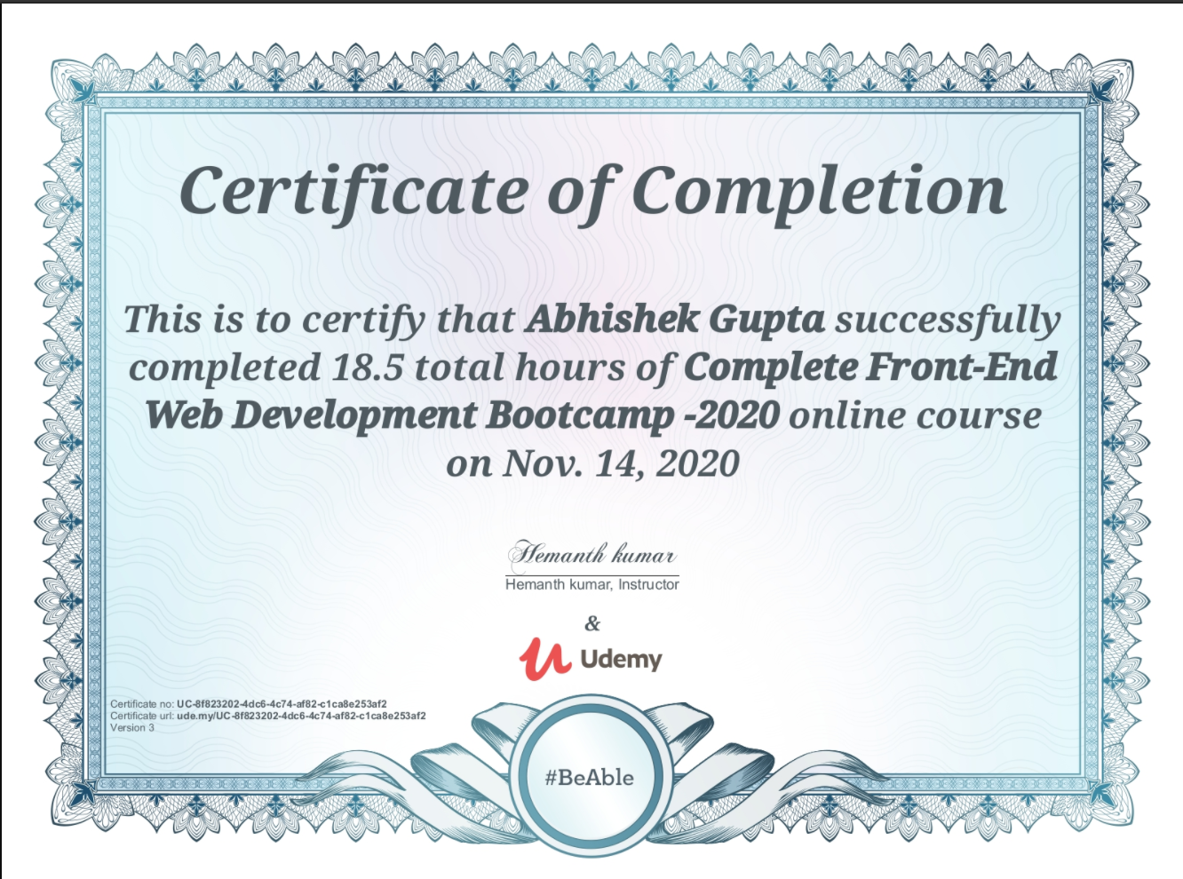

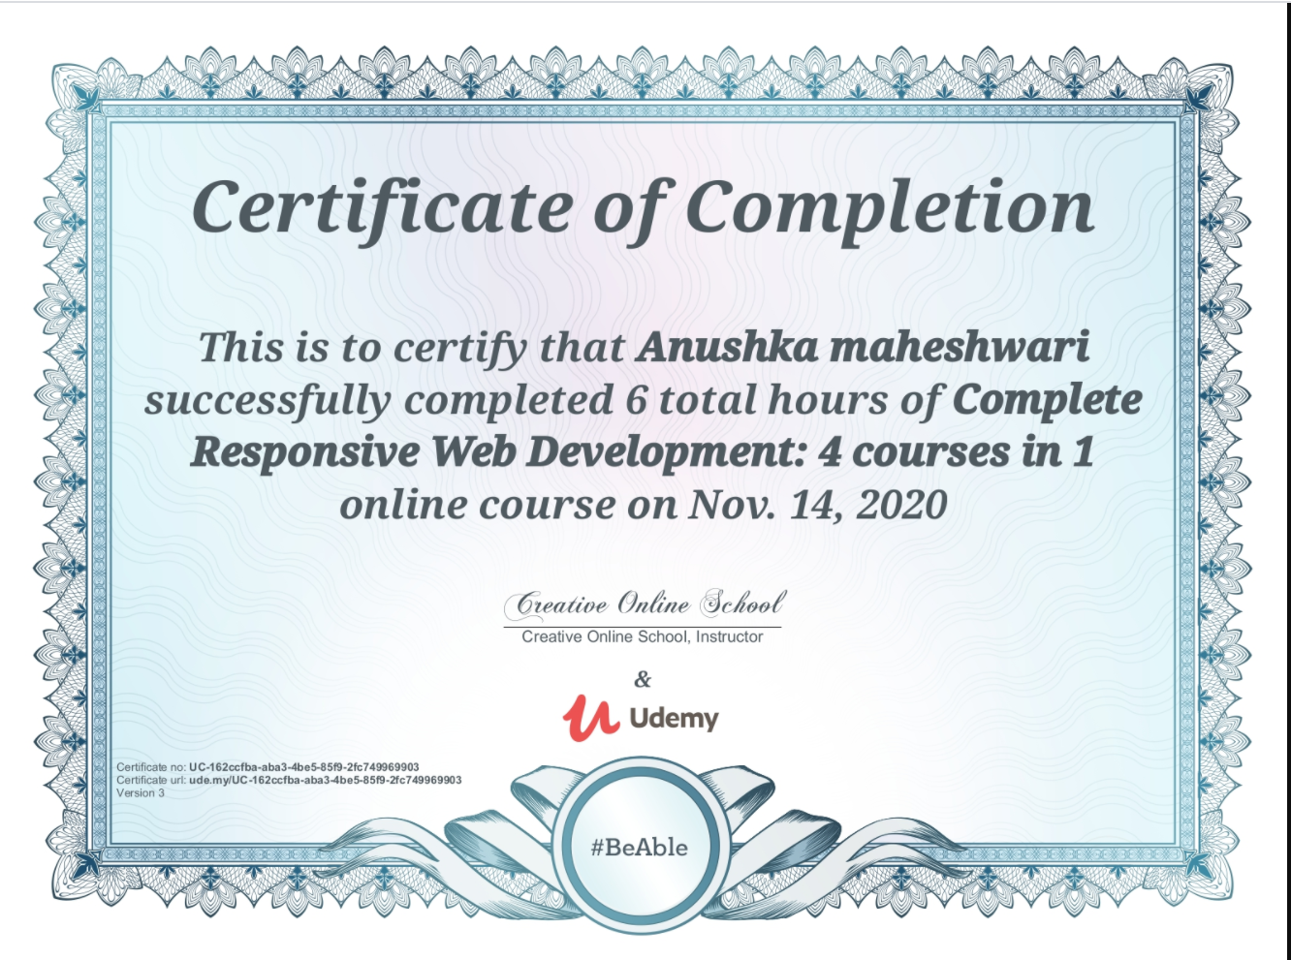

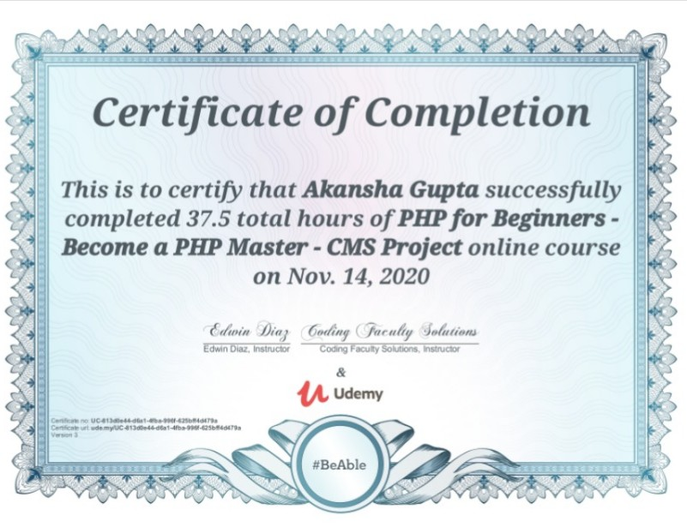

**ACKNOWLEDGEMENT**

It gives us a great sense of pleasure to present the report of the B. Tech Mini Project undertaken during B. Tech. Third Year. This project in itself is an acknowledgement to the inspiration, drive and technical assistance contributed to it by many individuals. This project would never have seen the light of the day without the help and guidance that we have received.

Our heartiest thanks to Dr. (Prof). Anand Singh Jalal, Head of Dept., Department of CEA for providing us with an encouraging platform to develop this project, which thus helped us in shaping our abilities towards a constructive goal.

We owe special debt of gratitude to Mr. Anand Gupta, Technical Trainer, for his constant support and guidance throughout the course of our work. His sincerity, thoroughness and perseverance have been a constant source of inspiration for us. He has showered us with all his extensively experienced ideas and insightful comments at virtually all stages of the project & has also taught us about the latest industry-oriented technologies.

We also do not like to miss the opportunity to acknowledge the contribution of all faculty members of the department for their kind guidance and cooperation during the development of our project. Last but not the least, we acknowledge our friends for their contribution in the completion of the project.

**ABHISHEK GUPTA**

**AKANSHA GUPTA**

**ANUSHKA MAHESHWARI**

**Abstract:**

The project was to raise funds for NGO Organizations and to create awareness for the NGO across India. The use of digital marketing was essential to boost the presence of NGO across geographies. NGO is a non-governmental organization registered as a public charitable trust in India. NGOs in India onestop, integrated services reached out to over 400,000 individuals in states of Gujarat, Rajasthan and Maharashtra. Since 1989, NGO has facilitated participatory processes that improve the quality of life for the urban and rural poor. NGOs has carried out various programs for slum like Integrated Slum Development Program . NGOs envisions inclusive and empowered communities and individuals. The program aims at making human settlements equitable living environments where all residents and vulnerable people have access to health, education, essential infrastructure services and livelihood options, irrespective of their economic and social status. Technology makes it possible to build applications and websites where multiple parties can execute transactions without the need for a trusted, central authority. The various campaigns run on the crowd funding platforms like Give India and Global Giving are used to raise funds. The main concern of the NGO was its awareness, it was hardly noticeable. My part of the project was to create awareness of NGO not only in any particular state but also across India. Spreading awareness across different locations was something that could be addressed using the Google Grant. The Google Grant allows the NGOs to run their advertisement for free and highlight the organization across different Geographies. For NGOs there are some online services and some offline services. non-governmental organizations are working with papers from different states in India. Even donations are taken manually from the members.so it difficult to keep all record manually. Current system all work is done manually and it is so difficult to manage the data manually.to make donation online a new computer based application is required. Sometimes it might be possible that someone really wants to help people, but they cant. This online service will helpful to that person. Helping Hands create a website where visitor can register become a member of our NGO. provide a facility that event details send via news to they member and can see the event details . member can also give suggestions as well as feedback to the Helping hands associated NGOs.

**Table of Contents**

|  |  |
| --- | --- |
| Declaration | ii |
| Certificate | iii |
| Acknowledgments | Iv |
| Abstract | V |
| Table of Contents | Vi |
| 1. **Introduction** | **1** |
| 1.1 Motivation and Overview | 1 |
| 1.2 Objective | 1 |
| 1. **Software Requirement Analysis** | **2** |
| 2.1 Define the problem ………………………………………………….. | 3 |
| 2.2 Define the modules and their functionalities (SRS) ……………..………………………………… | 4 |
| 1. **Software Design** | **19** |
| 3.1 ……………………….………………………… | 16 |
| 3.2 ……………………..…………………. | 17 |
| 1. **Testing** | **22** |
| 4.1 ………….……………………………………… | 22 |
| 4.2 ……………………..…………………. | 22 |
| 1. **Implementation and User Interface** | **31** |
| 5.1 ……………………………........ | 27 |
| 5.2 ….……………………………………………... | 27 |
| **References/Bibliography** | **89** |
| 1. **Appendices** | **90** |

Chaper-1

**Introduction :**

The project was to raise funds for NGO Organizations and to create awareness for the NGO across India. The use of digital marketing was essential to boost the presence of NGO across geographies. NGO is a non-governmental organization registered as a public charitable trust in India. NGOs in India on stop, integrated services reached out to over 400,000 individuals in states of Gujarat, Rajasthan and Maharashtra. Since 1989, NGO has facilitated participatory processes that improve the quality of life for the urban and rural poor. NGOs has carried out various programs for slum like Integrated Slum Development Program . NGOs envisions inclusive and empowered communities and individuals. The program aims at making human settlements equitable living environments where all residents and vulnerable people have access to health, education, essential infrastructure services and livelihood options, irrespective of their economic and social status. Technology makes it possible to build applications and websites where multiple parties can execute transactions without the need for a trusted, central authority. The various campaigns run on the crowd funding platforms like Give India and Global Giving are used to raise funds. The main concern of the NGO was its awareness, it was hardly noticeable. My part of the project was to create awareness of NGO not only in any particular state but also across India. Spreading awareness across different locations was something that could be addressed using the Google Grant. The Google Grant allows the NGOs to run their advertisement for free and highlight the organization across different Geographies. For NGOs there are some online services and some offline services. non-governmental organizations are working with papers from different states in India. Even donations are taken manually from the members.so it difficult to keep all record manually. Current system all work is done manually and it is so difficult to manage the data manually.to make donation online a new computer based application is required. Sometimes it might be possible that someone really wants to help people, but they cant. This online service will helpful to that person. Helping Hands create a website where visitor can register become a member of our NGO. provide a facility that event details send via news to they member and can see the event details . member can also give suggestions as well as feedback to the Helping hands associated NGOs.

**Objective:**

Fundraising is essential for the survival and success of non profit and charitable organizations. In fact, fundraising campaigns are often the primary focus of these organizations because without operating capital, they can’t provide the services necessary to fulfil their main goals. Before the advent of digital marketing, fundraising was primarily focused on obtaining as many donations as possible, but outreach efforts in today’s competitive environment must now focus on other equally important objectives.

**Raise Money for Operating Costs:**

Non profits must meet operating expenses to stay in business. These expenses include rent, utilities, liability insurance, payroll, buying office equipment and furniture, and launching campaigns for upcoming charitable events, and community outreach programs. Without the money from fundraising efforts, charitable organizations cannot meet these operating costs nor function the way they’re intended. The one risk, however, is that if too much fundraising money is allocated toward staff salaries, it could jeopardize the organization’s tax-exempt status.

**Fund an Endowment:**

Fundraising can also help a nonprofit organization establish an endowment, which is a restricted fund that only allows an organization to spend the interest that accrues from the fund. That means organizations can’t spend the principal funds in an endowment, which allows the original endowment to grow over a period of time. The benefit of an endowment is that it provides financial security for charitable organizations, helping them survive economic downturns and lower-than-expected donations from year to year.

**Raising Awareness of Issues:**

Sometimes raising awareness about an issue is a crucial part of fixing the issue itself. Charities may aim to raise awareness in their mission statements, but also may enact policies to reach specific awareness objectives. For example, a charity that aims to raise awareness about a pet overpopulation problem might want to provide outreach to students in a local school, with the objective of compelling families to spay or neuter their pets. Charities can raise awareness in many ways, such as holding educational events, writing monthly newsletters or starting T-shirt or bumper sticker campaigns, for instance.

**Education, Training and Employment:**

Giving people the skills they need to move on in life. Basically, we provide all these in a conclusive form:

• Provide decent accommodation

• Provide high quality appropriate support

• Provide individual person centred development

• Enable individuals to be active members of the community

• Raise awareness of homelessness in the Reading area

• Maintain and develop effective partnerships with local agencies

**ADVANTAGES AND LIMITATIONS OF THIS APPLICATION:**

ADVANTAGES:

1.A donation is done to hand to hand with donors.

2.Event details will be sending through via news.

3.This project is for offline or online donors.

4.this system accept all type of donations. ex-toys, cash, clothes, etc

DISADVANTAGES:

1.Registered member can see information only on helping hand site.

2.user cannot directly contact. contact should be done only with site.

CHAPTER-2

**Problems & Challenges**

There were certain issues that were highlighted at the NGO

• The organization lacked awareness.

• The website was not listed on the first page of Google Search.

• Different searches for NGO or CSR were unable to get the website on the first page.

• The actual projects were not being highlighted as the stories were not highlighted efficiently.

• The organization lacked tracking of the corporate leads.

• The corporate funding questionnaire was not efficient to capture the complete data.

• The organization lacked awareness among corporates.

• There was a need to reach to corporates in person to present the projects undergone in SAATH and pitch in for long term tie ups.

**DEFINITIONS**

**VISUAL STUDIO :**

Visual Studio Code is a source-code editor that can be used with a variety of programming languages, including  [Java](https://en.wikipedia.org/wiki/Java_(programming_language)), [JavaScript](https://en.wikipedia.org/wiki/JavaScript), [Go](https://en.wikipedia.org/wiki/Go_(programming_language)), [Node.js](https://en.wikipedia.org/wiki/Node.js) and [C++](https://en.wikipedia.org/wiki/C%2B%2B). It is based on the [Electron](https://en.wikipedia.org/wiki/Electron_(software_framework)) framework, which is used to develop [Node.js](https://en.wikipedia.org/wiki/Node.js) [Web applications](https://en.wikipedia.org/wiki/Web_application) that run on the [Blink layout engine](https://en.wikipedia.org/wiki/Blink_layout_engine). Visual Studio Code employs the same editor component (codenamed "Monaco") used in [Azure DevOps](https://en.wikipedia.org/wiki/Azure_DevOps_Server) (formerly called Visual Studio Online and Visual Studio Team Services).

Instead of a project system, it allows users to open one or more directories, which can then be saved in workspaces for future reuse. This allows it to operate as a [language-agnostic](https://en.wikipedia.org/wiki/Language-agnostic) code editor for any language. It supports a number of programming languages and a set of features that differs per language. Unwanted files and folders can be excluded from the project tree via the settings. Many Visual Studio Code features are not exposed through menus or the user interface, but can be accessed via the command palette.

Visual Studio Code can be extended via [extensions](https://en.wikipedia.org/wiki/Plug-in_(computing)), available through a central repository. This includes additions to the editor and language support. A notable feature is the ability to create extensions that add support for new [languages](https://en.wikipedia.org/wiki/Programming_language), [themes](https://en.wikipedia.org/wiki/Theme_(computing)), and [debuggers](https://en.wikipedia.org/wiki/Debugger), perform [static code analysis](https://en.wikipedia.org/wiki/Static_code_analysis), and add [code linters](https://en.wikipedia.org/wiki/Lint_(software)) using the [Language Server Protocol](https://en.wikipedia.org/wiki/Language_Server_Protocol).

Visual Studio Code includes multiple extensions for FTP, allowing the software to be used as a free alternative for web development. Code can be synced between the editor and the server, without downloading any extra software.

Visual Studio Code allows users to set the [code page](https://en.wikipedia.org/wiki/Code_page) in which the active document is saved, the [newline](https://en.wikipedia.org/wiki/Newline) character, and the programming language of the active document. This allows it to be used on any platform, in any locale, and for any given programming language.

**WEB BROWSER**  :

A web browser (commonly referred to as a browser) is a [software application](https://en.wikipedia.org/wiki/Software_application) for accessing information on the [World Wide Web](https://en.wikipedia.org/wiki/World_Wide_Web). Each individual [web page](https://en.wikipedia.org/wiki/Web_page), image, and video is identified by a distinct [Uniform Resource Locator](https://en.wikipedia.org/wiki/URL) (URL), enabling browsers to retrieve these resources from a [web server](https://en.wikipedia.org/wiki/Web_server) and display them on the [user](https://en.wikipedia.org/wiki/User_(computing))'s device.

A web browser is not the same thing as a [search engine](https://en.wikipedia.org/wiki/Web_search_engine), though the two are often confused. For a user, a search engine is just a [website](https://en.wikipedia.org/wiki/Website), such as [google.com](https://en.wikipedia.org/wiki/Google_Search), that stores searchable data about other websites. But to connect to a website's server and display its web pages, a user needs to have a web browser installed on their device.

The most popular browsers are [Chrome](https://en.wikipedia.org/wiki/Google_Chrome), [Firefox](https://en.wikipedia.org/wiki/Firefox), [Safari](https://en.wikipedia.org/wiki/Safari_(web_browser)), [Internet Explorer](https://en.wikipedia.org/wiki/Internet_Explorer), and [Edge](https://en.wikipedia.org/wiki/Microsoft_Edge)

**BOOTSTRAP:**

Bootstrap is a web framework that focuses on simplifying the development of informative web pages (as opposed to web apps). The primary purpose of adding it to a web project is to apply Bootstrap's choices of color, size, font and layout to that project. As such, the primary factor is whether the developers in charge find those choices to their liking. Once added to a project, Bootstrap provides basic style definitions for all HTML elements. The result is a uniform appearance for prose, tables and form elements across web browsers. In addition, developers can take advantage of CSS classes defined in Bootstrap to further customize the appearance of their contents. For example, Bootstrap has provisioned for light- and dark colored tables, page headings, more prominent pull quotes, and text with a highlight. Bootstrap also comes with several JavaScript components in the form of jQuery plugins. They provide additional user interface elements such as dialog boxes, tooltips, and carousels. Each Bootstrap component consists of an HTML structure, CSS declarations, and in some cases accompanying JavaScript code. They also extend the functionality of some existing interface elements, including for example an auto-complete function for input fields.

**MYSQL :**

MySQL  is an [open-source](https://en.wikipedia.org/wiki/Open-source_software) [relational database management system](https://en.wikipedia.org/wiki/Relational_database_management_system) (RDBMS). Its name is a combination of "My", the name of co-founder [Michael Widenius](https://en.wikipedia.org/wiki/Michael_Widenius)'s daughter, and "[SQL](https://en.wikipedia.org/wiki/SQL)", the abbreviation for [Structured Query Language](https://en.wikipedia.org/wiki/Structured_Query_Language). A [relational database](https://en.wikipedia.org/wiki/Relational_database) organizes data into one or more data tables in which data types may be related to each other; these relations help structure the data. SQL is a language programmers use to create, modify and extract data from the relational database, as well as control user access to the database. In addition to relational databases and SQL, an RDBMS like MySQL works with an [operating system](https://en.wikipedia.org/wiki/Operating_system) to implement a relational database in a computer's storage system, manages users, allows for network access and facilitates testing database integrity and creation of backups.

MySQL is [free and open-source software](https://en.wikipedia.org/wiki/Free_and_open-source_software) under the terms of the [GNU General Public License](https://en.wikipedia.org/wiki/GNU_General_Public_License), and is also available under a variety of [proprietary](https://en.wikipedia.org/wiki/Proprietary_software) licenses. MySQL was owned and sponsored by the [Swedish](https://en.wikipedia.org/wiki/Sweden) company [MySQL AB](https://en.wikipedia.org/wiki/MySQL_AB), which was bought by [Sun Microsystems](https://en.wikipedia.org/wiki/Sun_Microsystems) (now [Oracle Corporation](https://en.wikipedia.org/wiki/Oracle_Corporation)). In 2010, when Oracle acquired Sun, Widenius [forked](https://en.wikipedia.org/wiki/Fork_(software_development)) the [open-source](https://en.wikipedia.org/wiki/Open-source) MySQL project to create [MariaDB](https://en.wikipedia.org/wiki/MariaDB).

MySQL has stand-alone clients that allow users to interact directly with a MySQL database using SQL, but more often MySQL is used with other programs to implement applications that need relational database capability. MySQL is a component of the [LAMP](https://en.wikipedia.org/wiki/LAMP_(software_bundle)) [web application](https://en.wikipedia.org/wiki/Web_application) [software stack](https://en.wikipedia.org/wiki/Software_stack) (and [others](https://en.wikipedia.org/wiki/List_of_AMP_packages)), which is an acronym for [Linux](https://en.wikipedia.org/wiki/Linux), [Apache](https://en.wikipedia.org/wiki/Apache_HTTP_Server), MySQL, [Perl](https://en.wikipedia.org/wiki/Perl)/[PHP](https://en.wikipedia.org/wiki/PHP)/[Python](https://en.wikipedia.org/wiki/Python_(programming_language)). MySQL is used by many database-driven web applications, including [Drupal](https://en.wikipedia.org/wiki/Drupal), [Joomla](https://en.wikipedia.org/wiki/Joomla), [phpBB](https://en.wikipedia.org/wiki/PhpBB" \o "PhpBB), and [WordPress](https://en.wikipedia.org/wiki/WordPress). MySQL is also used by many popular [websites](https://en.wikipedia.org/wiki/Website), including [Facebook](https://en.wikipedia.org/wiki/Facebook), [Flickr](https://en.wikipedia.org/wiki/Flickr), [MediaWiki](https://en.wikipedia.org/wiki/MediaWiki" \o "MediaWiki), [Twitter](https://en.wikipedia.org/wiki/Twitter), and [YouTube](https://en.wikipedia.org/wiki/YouTube).

**TOOLS USED**

**Technical Feasibility:**

The proposed system is developed using HTML, CSS and bootstrap as front-end tool and php and js node as the back end. The proposed system needs a Personal Web Server to serve the requests submitted by the users. The Web browser is used to view the web page that is available within the Windows operating system itself. The proposed system will run under Win9x, NT, and win2000 environment. As Windows is very user friendly and GUI OS it is very easy to use. All the required hardware and software are readily available in the market. Hence the system is technically feasible.

**Operational Feasibility:** The proposed system is operationally feasible because of the following reasons.

• The customer is benefited more as most of his time is saved. The customer is serviced at his place of work.

• The purpose of this website serves the good and needy people.

**Economical Feasibility:** As the necessary hardware and software are available in the market at a low cost, the initial investment is the only cost incurred and does not need any further enhancements. Hence it is economically feasible. The system is feasible in all respects and hence it encourages taking up the system design. We have used different languages and technologies for preparing the project .

**HTML**

The extended reach of information and services to customers that the Internet has enabled, has created a new challenge for the developer. The developer should develop a user interface that is distributable, available on multiple platforms and supports a wide range of client environments from handheld wireless devices to high-end workstations. So to maintain a broad reach to client environments and to achieve greatest compatibility with all browsers, this system uses standard HTML. Hyper Text Markup Language is the standard language for creating documents for the World Wide Web. An HTML document is a text file, which contains the elements, in the form of tags that a web browser uses to display text, multimedia objects, and hyperlinks using HTML; we can format a document for display and add hyperlinks to other documents. The user interface has been designed in HTML hence can be browsed in any web browser.

HTML can embed programs written in a [scripting language](https://en.wikipedia.org/wiki/Scripting_language) such as [JavaScript](https://en.wikipedia.org/wiki/JavaScript), which affects the behavior and content of web pages. Inclusion of CSS defines the look and layout of content. The [World Wide Web Consortium](https://en.wikipedia.org/wiki/World_Wide_Web_Consortium) (W3C), maintainer of both the HTML and the CSS standards, has encouraged the use of CSS over explicit presentational HTML since 1997.

HTML code ensures the proper formatting of text and images so that your [Internet browser](https://www.computerhope.com/jargon/b/browser.htm) may display them as they are intended to look. Without HTML, a browser would not know how to display text as [elements](https://www.computerhope.com/jargon/h/html-element.htm) or load images or other elements. HTML also provides a basic structure of the page, upon which [Cascading Style Sheets](https://www.computerhope.com/jargon/c/css.htm) are overlaid to change its appearance. One could think of HTML as the bones (structure) of a web page, and CSS as its skin (appearance).

**CSS (Cascading Style Sheets)**

**C**ascading **S**tyle **S**heets, fondly referred to as CSS, is a simple design language intended to simplify the process of making web pages presentable.

CSS handles the look and feel part of a web page. Using CSS, you can control the color of the text, the style of fonts, the spacing between paragraphs, how columns are sized and laid out, what background images or colors are used, layout designs, variations in display for different devices and screen sizes as well as a variety of other effects.

CSS is easy to learn and understand but it provides powerful control over the presentation of an HTML document. Most commonly, CSS is combined with the markup languages HTML or XHTML.

**Advantage Of CSS**

**CSS saves time** − You can write CSS once and then reuse same sheet in multiple HTML pages. You can define a style for each HTML element and apply it to as many Web pages as you want.

**Pages load faster** − If you are using CSS, you do not need to write HTML tag attributes every time. Just write one CSS rule of a tag and apply it to all the occurrences of that tag. So less code means faster download times.

**Easy maintenance** − To make a global change, simply change the style, and all elements in all the web pages will be updated automatically.

**Superior styles to HTML** − CSS has a much wider array of attributes than HTML, so you can give a far better look to your HTML page in comparison to HTML attributes.

**Multiple Device Compatibility** − Style sheets allow content to be optimized for more than one type of device. By using the same HTML document, different versions of a website can be presented for handheld devices such as PDAs and cell phones or for printing.

**Global web standards** − Now HTML attributes are being deprecated and it is being recommended to use CSS. So its a good idea to start using CSS in all the HTML pages to make them compatible to future browsers.

**PHP:**

PHP is a general-purpose scripting language especially suited to web development. It was originally created by Danish-Canadian programmer Rasmus Lerdorf in 1994; the PHP reference implementation is now produced by The PHP Group. PHP originally stood for Personal Home Page, but it now stands for the recursive initialism PHP code is usually processed on a web server by a PHP interpreter implemented as a module, a daemon or as a Common Gateway Interface (CGI) executable. On a web server, the result of the interpreted and executed PHP code – which may be any type of data, such as generated HTML or binary image data – would form the whole or part of a HTTP response. Various web template systems, web content management systems, and web frameworks exist which can be employed to orchestrate or facilitate the generation of that response. Additionally, PHP can be used for many programming tasks outside of the web context, such as standalone graphical applications and robotic drone control. Arbitrary PHP code can also be interpreted and executed via command-line interface

**BOOTSTRAP**

Bootstrap is a web framework that focuses on simplifying the development of informative web pages (as opposed to web apps). The primary purpose of adding it to a web project is to apply Bootstrap's choices of color, size, font and layout to that project. As such, the primary factor is whether the developers in charge find those choices to their liking. Once added to a project, Bootstrap provides basic style definitions for all HTML elements. The result is a uniform appearance for prose, tables and form elements across web browsers. In addition, developers can take advantage of CSS classes defined in Bootstrap to further customize the appearance of their contents. For example, Bootstrap has provisioned for light- and dark colored tables, page headings, more prominent pull quotes, and text with a highlight. Bootstrap also comes with several JavaScript components in the form of jQuery plugins. They provide additional user interface elements such as dialog boxes, tooltips, and carousels. Each Bootstrap component consists of an HTML structure, CSS declarations, and in some cases accompanying JavaScript code. They also extend the functionality of some existing interface elements, including for example an auto-complete function for input fields.

## Getting Started with Bootstrap Basics

Bootstrap is available in two forms; as a precompiled version, and as a source code version. The source code version uses the [Less](http://lesscss.org/) CSS preprocessor, but if you are more into Sass, there is an [official Sass port of Bootstrap](https://github.com/twbs/bootstrap-sass) also available. To make it easier to make use of CSS vendor prefixes, Bootstrap uses [Autoprefixer](https://github.com/postcss/autoprefixer" \t "https://www.toptal.com/front-end/_blank).

The source code version comes styles source code written in Less (or Sass), all the JavaScript, and accompanying documentation. This allows more ambitious designers and developers to change and customize, at their will, all the provided styles, and to build their own version of Bootstrap.

## JAVA SCRIPT (JS)

**JavaScript** often abbreviated as **JS**, is a [high-level](https://en.wikipedia.org/wiki/High-level_programming_language), [interpreted](https://en.wikipedia.org/wiki/Interpreted_language) [programming language](https://en.wikipedia.org/wiki/Programming_language) that conforms to the [ECMAScript](https://en.wikipedia.org/wiki/ECMAScript) specification. It is a programming language that is characterized as [dynamic](https://en.wikipedia.org/wiki/Dynamic_programming_language), [weakly typed](https://en.wikipedia.org/wiki/Weak_typing), [prototype-based](https://en.wikipedia.org/wiki/Prototype-based_programming) and [multi-paradigm](https://en.wikipedia.org/wiki/Multi-paradigm_programming_language).

Alongside [HTML](https://en.wikipedia.org/wiki/HTML) and [CSS](https://en.wikipedia.org/wiki/CSS), JavaScript is one of the core technologies of the [World Wide Web](https://en.wikipedia.org/wiki/World_Wide_Web). JavaScript enables interactive [web pages](https://en.wikipedia.org/wiki/Web_page) and is an essential part of [web applications](https://en.wikipedia.org/wiki/Web_application). The vast majority of [websites](https://en.wikipedia.org/wiki/Website) use it, and major [web browsers](https://en.wikipedia.org/wiki/Web_browser) have a dedicated [JavaScript engine](https://en.wikipedia.org/wiki/JavaScript_engine) to execute it.

As a multi-paradigm language, JavaScript supports [event-driven](https://en.wikipedia.org/wiki/Event-driven_programming), [functional](https://en.wikipedia.org/wiki/Functional_programming), and [imperative](https://en.wikipedia.org/wiki/Imperative_programming) (including [object-oriented](https://en.wikipedia.org/wiki/Object-oriented_programming) and [prototype-based](https://en.wikipedia.org/wiki/Prototype-based_programming)) [programming styles](https://en.wikipedia.org/wiki/Programming_paradigm). It has [APIs](https://en.wikipedia.org/wiki/Application_programming_interface) for working with text, [arrays](https://en.wikipedia.org/wiki/Array_data_type), dates, [regular expressions](https://en.wikipedia.org/wiki/Regular_expression), and the [DOM](https://en.wikipedia.org/wiki/Document_Object_Model), but the language itself does not include any [I/O](https://en.wikipedia.org/wiki/Input/output), such as [networking](https://en.wikipedia.org/wiki/Computer_network), [storage](https://en.wikipedia.org/wiki/Data_storage), or [graphics](https://en.wikipedia.org/wiki/Computer_graphics) facilities. It relies upon the host environment in which it is embedded to provide these features.

Initially only implemented [client-side](https://en.wikipedia.org/wiki/Client-side) in web browsers, JavaScript engines are now embedded in many other types of host software, including [server-side](https://en.wikipedia.org/wiki/Server-side) in web servers and databases, and in non-web programs such as word processors and [PDF](https://en.wikipedia.org/wiki/Portable_Document_Format) software, and in runtime environments that make JavaScript available for writing mobile and desktop applications, including desktop widgets.

The terms Vanilla JavaScript and Vanilla JS refer to JavaScript not extended by any frameworks or additional libraries. Scripts written in Vanilla JS are plain JavaScript code.

Although there are similarities between JavaScript and [Java](https://en.wikipedia.org/wiki/Java_(programming_language)), including language name, [syntax](https://en.wikipedia.org/wiki/Syntax_(programming_languages)), and respective [standard libraries](https://en.wikipedia.org/wiki/Standard_library), the two languages are distinct and differ greatly in design. JavaScript was influenced by programming languages such as [Self](https://en.wikipedia.org/wiki/Self_(programming_language)) and [Scheme](https://en.wikipedia.org/wiki/Scheme_(programming_language)).

**FONT AWESOME**

Font Awesome is a [font](https://en.wikipedia.org/wiki/Font) and [icon](https://en.wikipedia.org/wiki/Icon_(computing)) toolkit based on [CSS](https://en.wikipedia.org/wiki/CSS) and [LESS](https://en.wikipedia.org/wiki/Less_(stylesheet_language)). It was made by Dave Gandy for use with [Twitter Bootstrap](https://en.wikipedia.org/wiki/Twitter_Bootstrap), and later was incorporated into the [BootstrapCDN](https://en.wikipedia.org/wiki/BootstrapCDN" \o "BootstrapCDN). Font Awesome has a 20% market share among those websites which use third-party Font Scripts on their platform, ranking it second place after [Google Fonts](https://en.wikipedia.org/wiki/Google_Fonts).

**Requirements:**

Following are the hardware and the software requirements for our project:

* 1. **a) Hardware:**
  + Laptop/Desktop
  + 1.8 GHz or faster processor. Quad-core or better recommended
  + 2 GB of RAM
  + Hard disk space: Minimum of 800MB up to 210GB of available space
  + Video card that supports a minimum display resolution of 720p (1280 by 720)

**b) Software:**

* + Windows 8.1 and above
  + Visual Studio
  + Windows Server 2016
  + .NET Framework 4.5 is required to install Visual Studio
  + Web Browser
  + Bootstrap
  + MSSQL

**Chapter-3**

**Software Design**

**Preliminary Design:** Preliminary design is basically concerned with deriving an overall picture of the system. Deriving entire system into modules and sub-modules while keeping Cohesion and Coupling factors in mind. Tools, which assist in preliminary design process, are Data Flow Diagrams.

**Code design:** The purpose of code is to facilitate the identification and retrieval for items of information. A code is an ordered collection of symbols designed to provide unique identification of an entity or attribute. To achieve unique identification there must be only one place where the identified entity or the attribute can be entered in the code; conversely there must be a place in the code for every thing that is to be identified. This mutually exclusive feature must be built into any coding system. The codes for this system are designed with two features in mind. Optimum human oriented use and machine efficiency. Length of the code range from length of one to length of five characteristics:

Ø The code structure is unique; ensuring that only one value of the code with a single meaning may be correctly applied to a given entity or attributes.

Ø The code structure is expansible allowing for growth of its set of entities and attributes.

Ø The code is concise and brief for recording, communication, transmission and storage efficiencies.

Ø They have a uniform size and format.

Ø The codes are simple so that the user can easily understand it.

Ø The codes are also versatile i.e., it is easy to modify to reflect necessary changers in condition, chart eristic and relationships of the encode entities.

Ø The codes are also easily storable for producing reports in a predetermined order of format.

Ø The codes are also stable and do not require being frequently updated thereby promoting user efficiency.

Ø The codes are also meaningful.

Ø They are also operable i.e., they are adequate for present and anticipate data processing both for machine and human use.

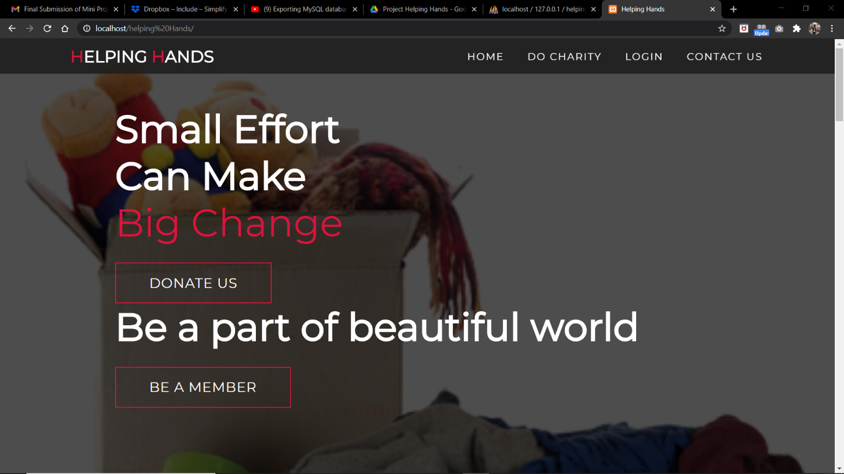

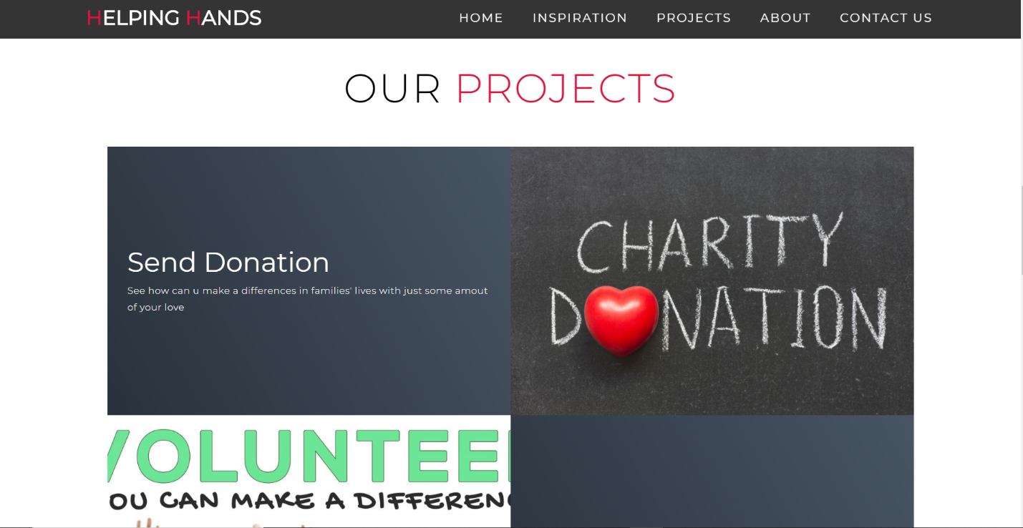

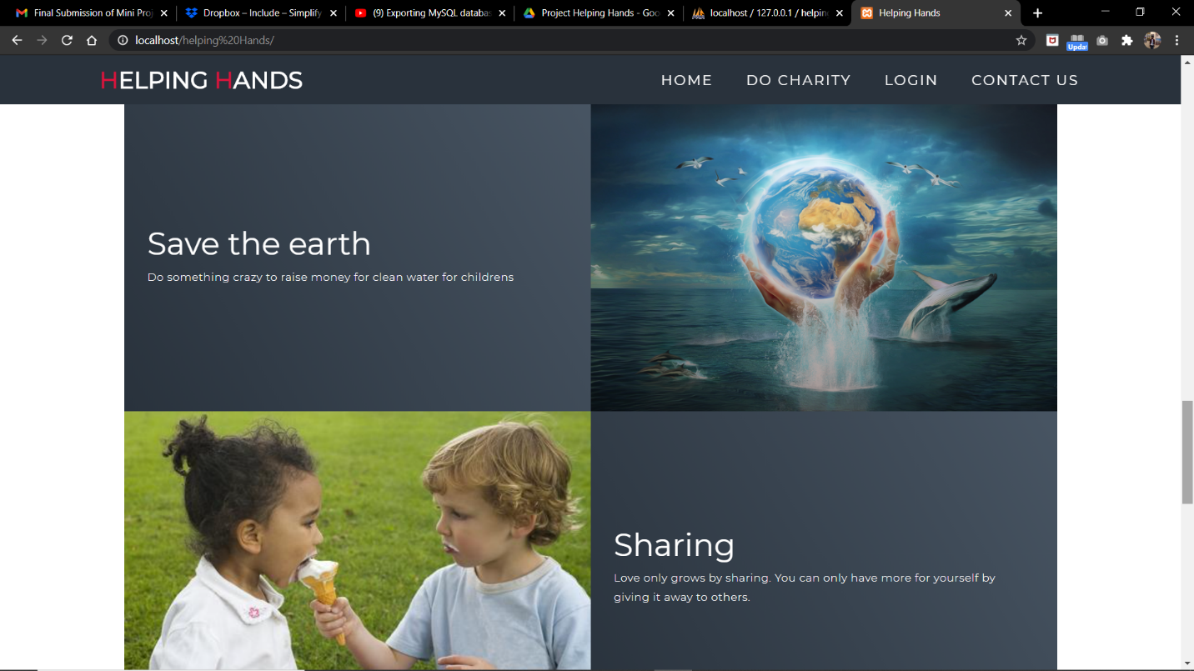

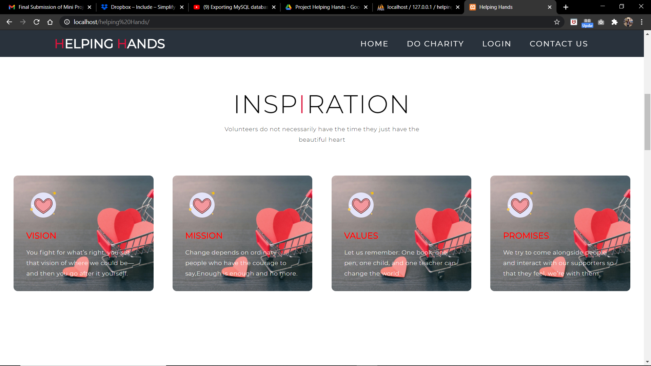

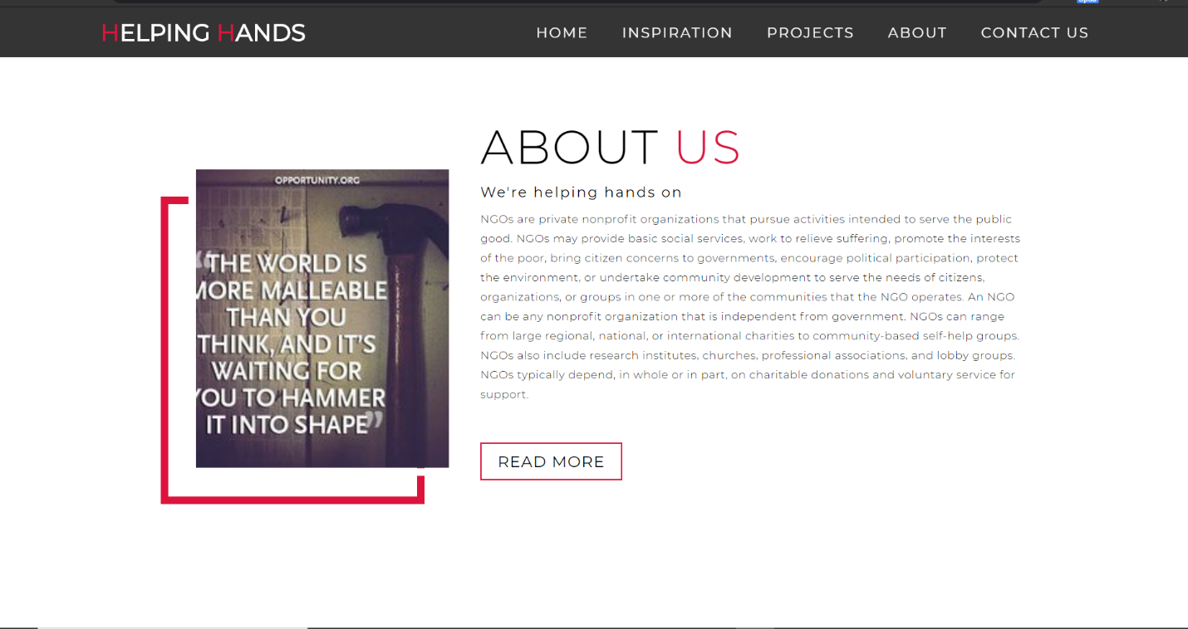



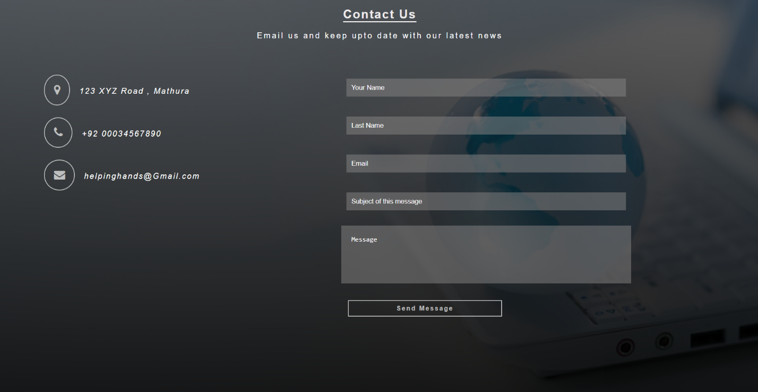

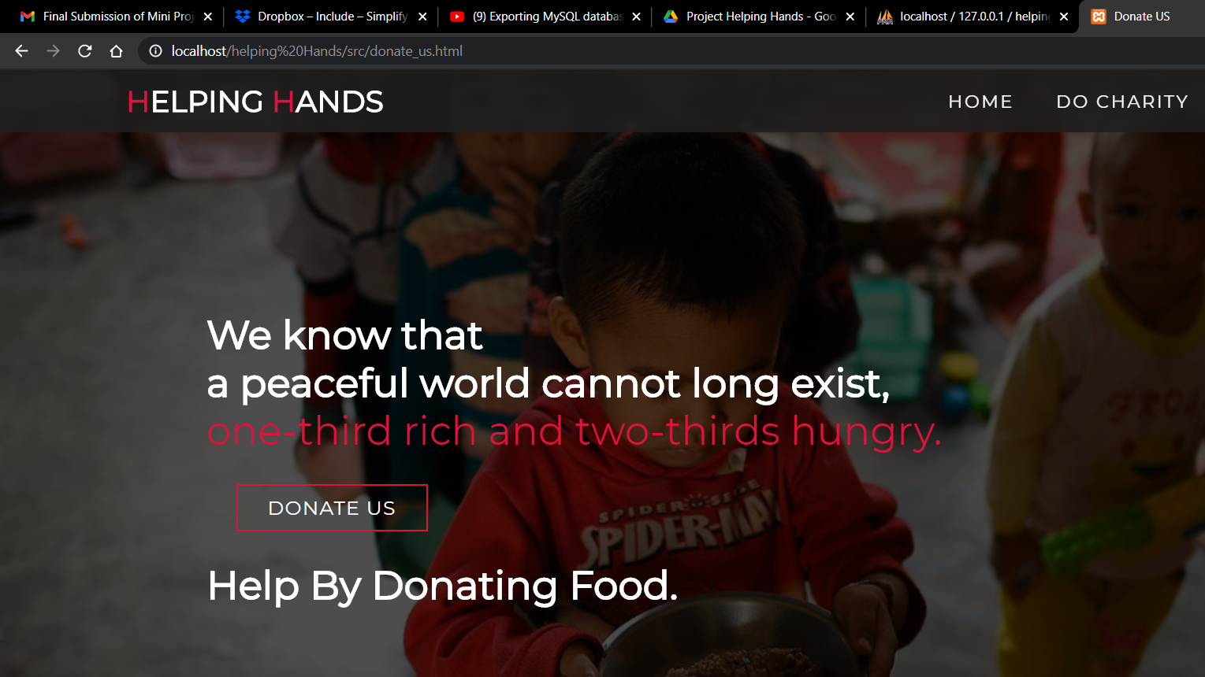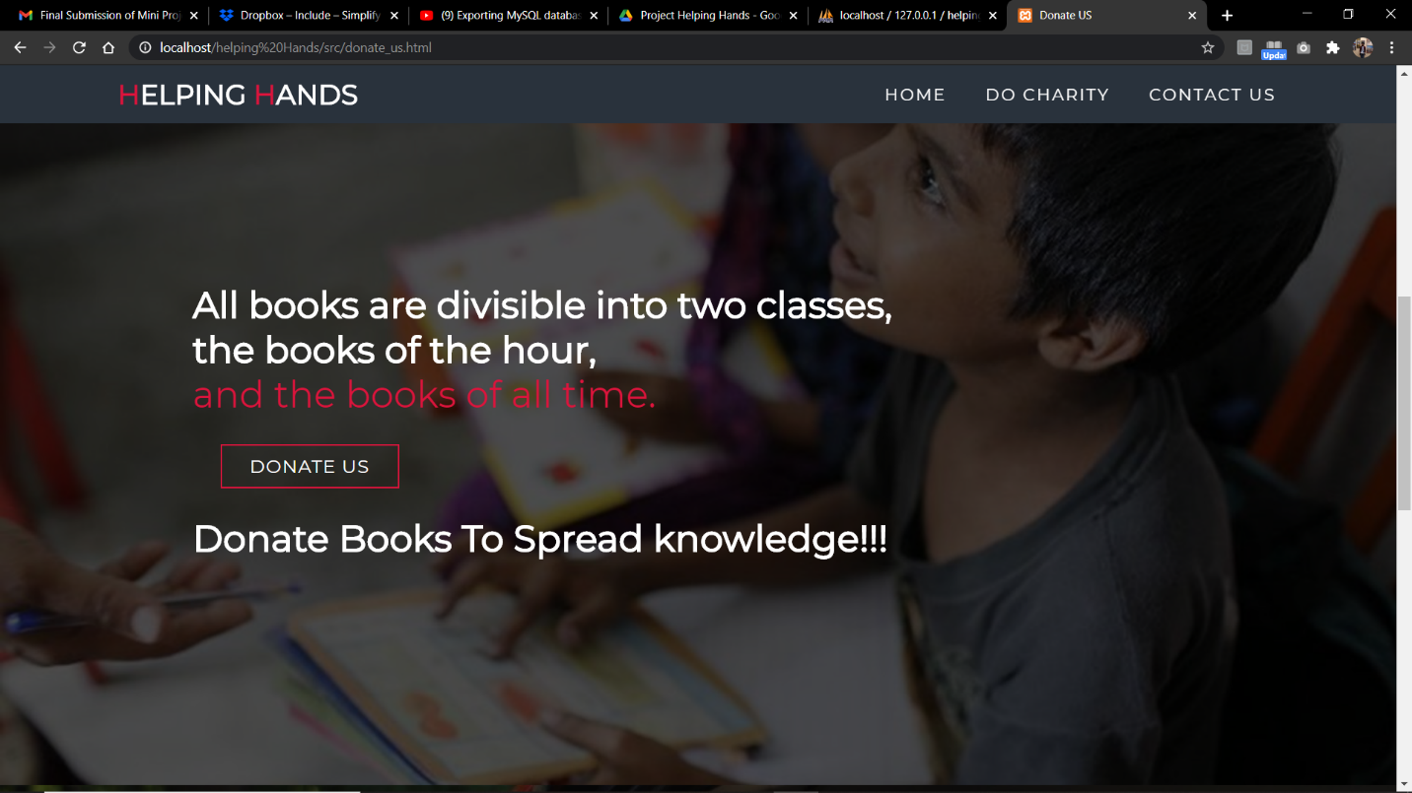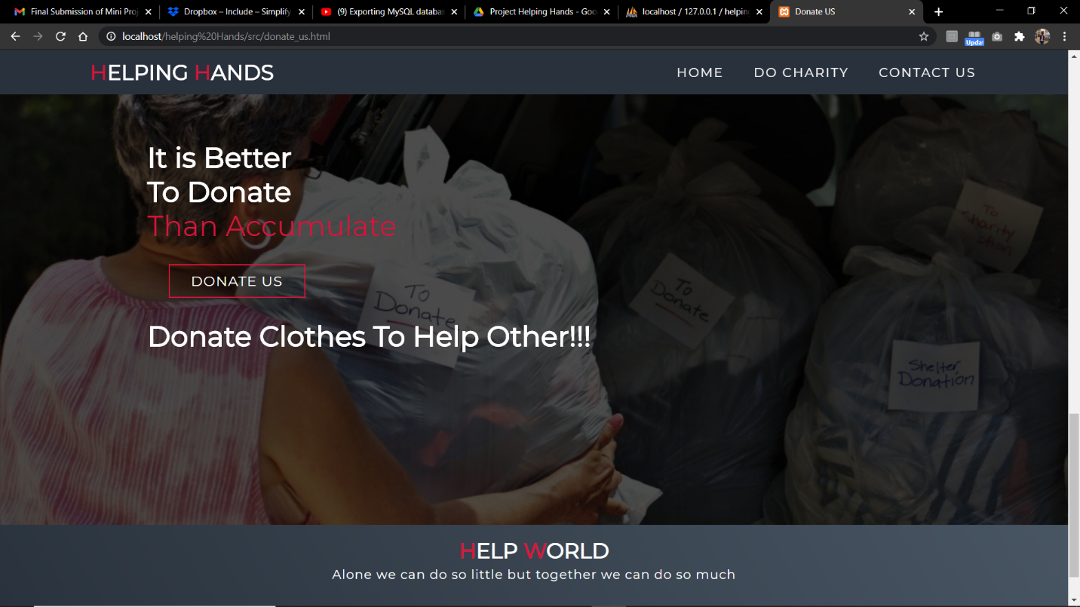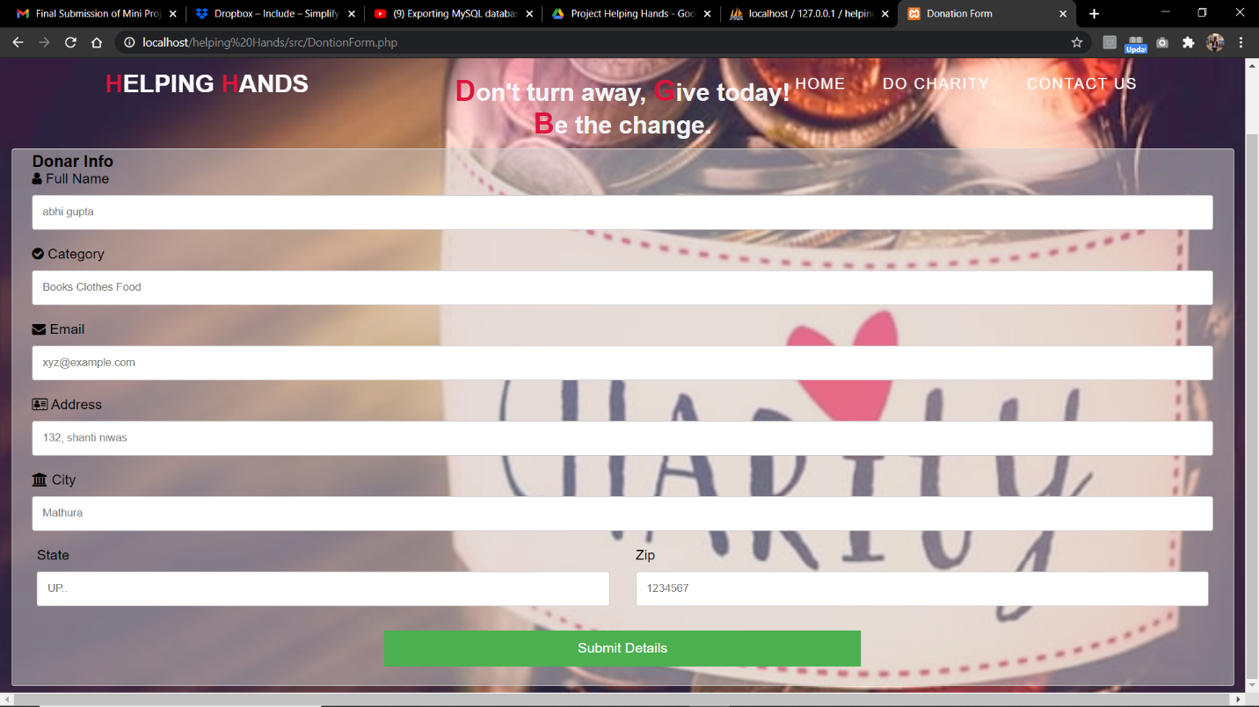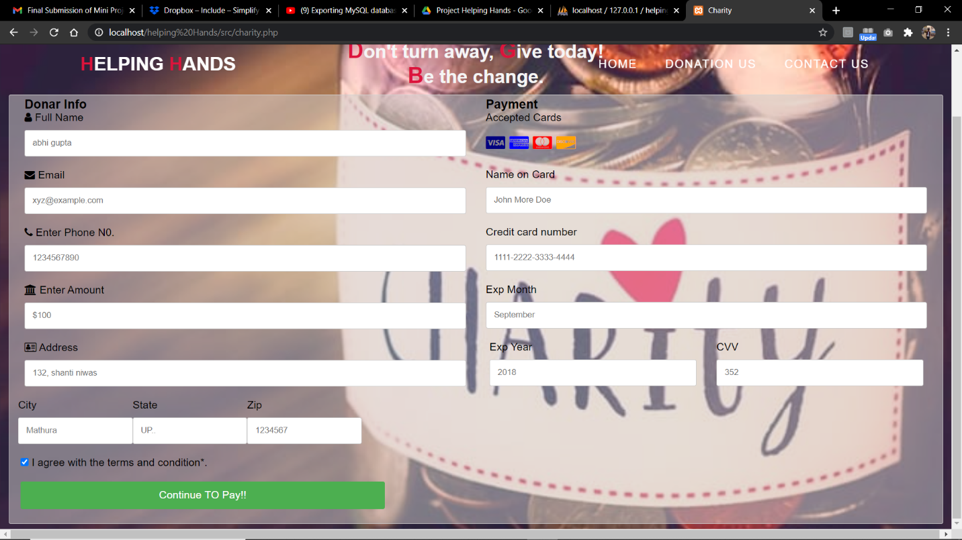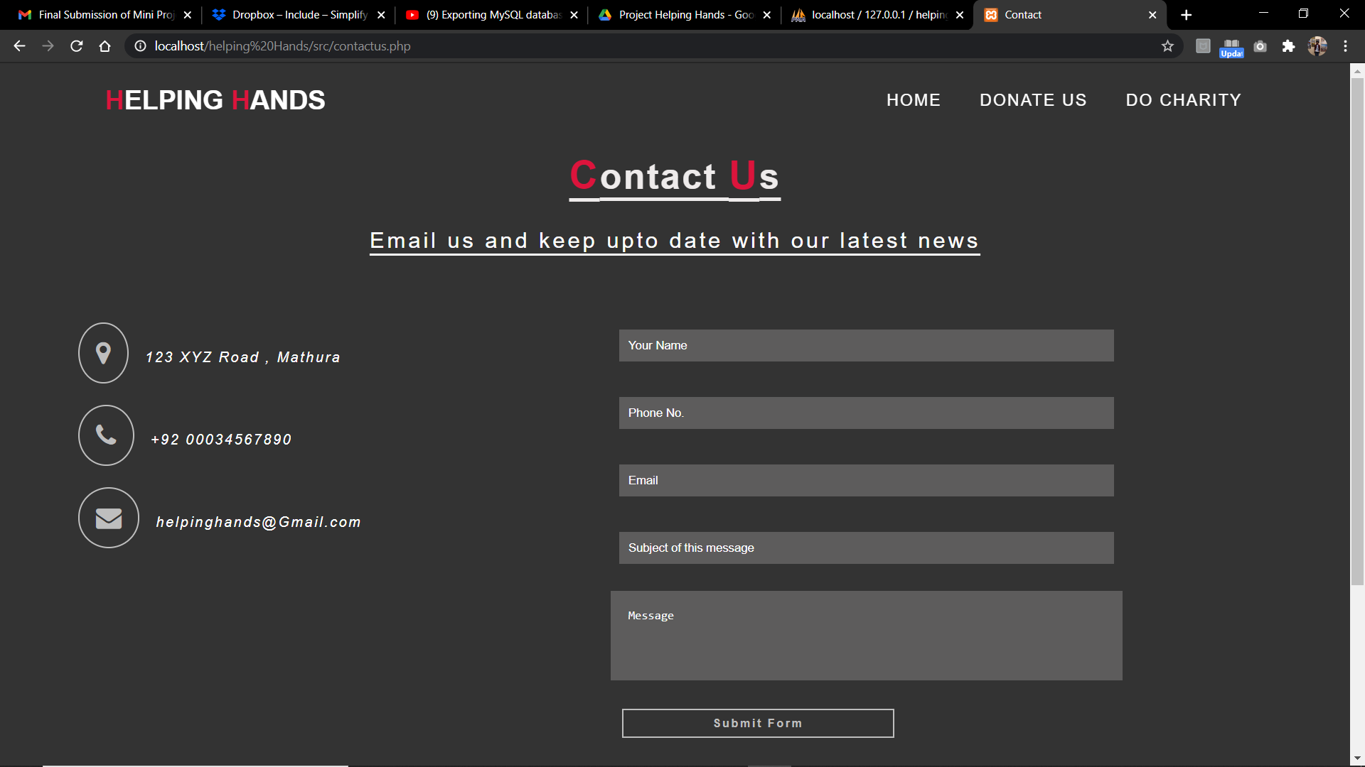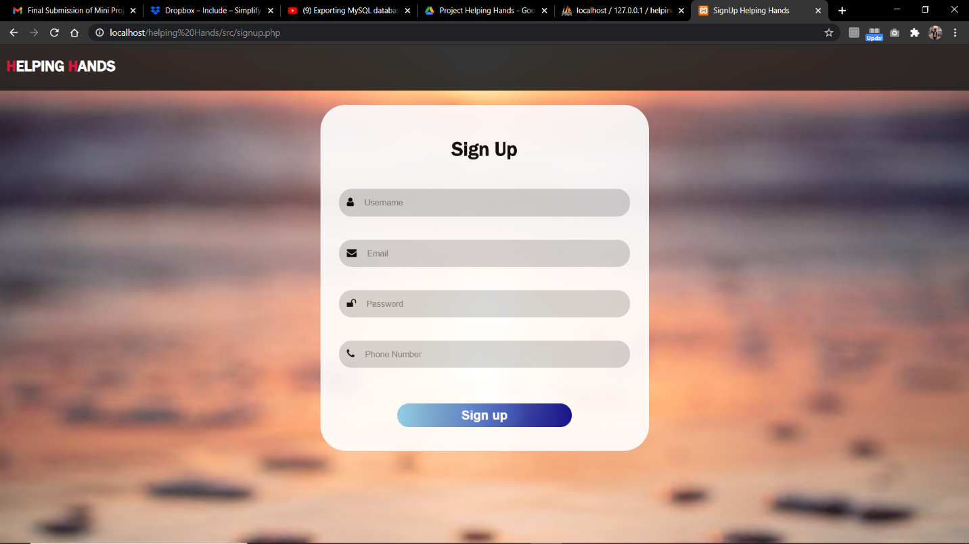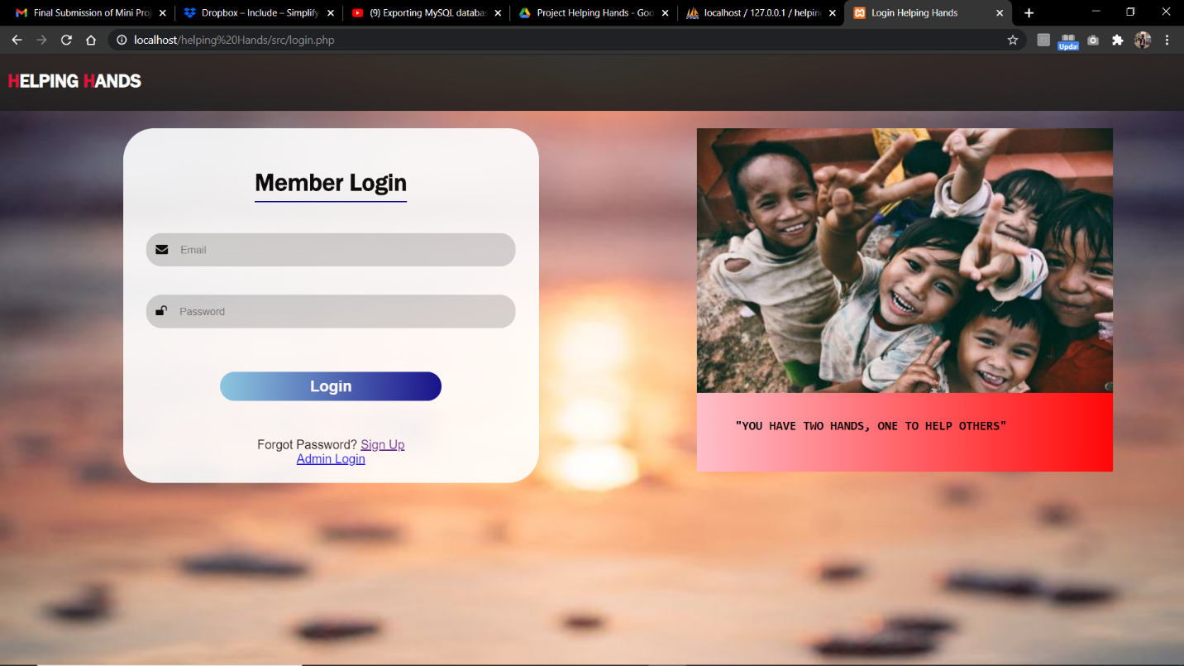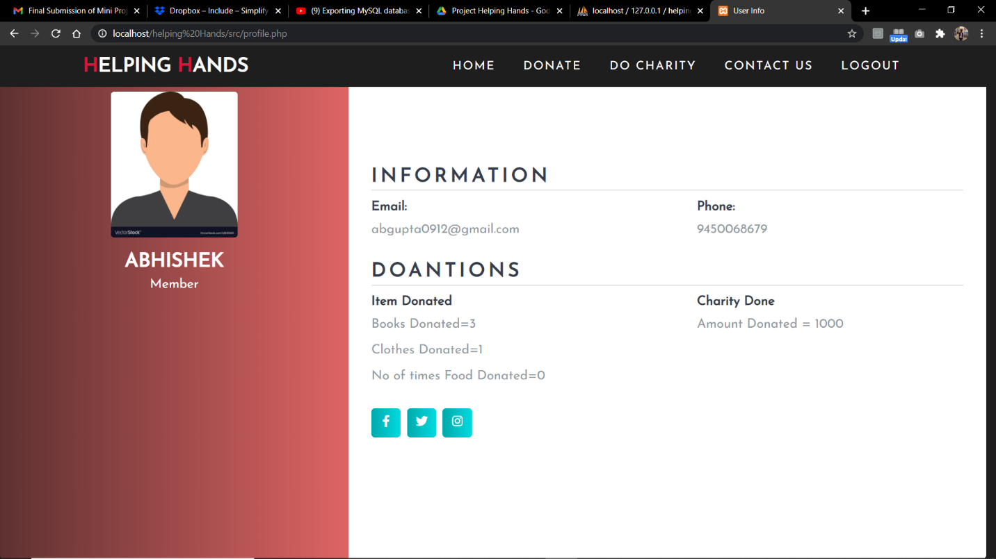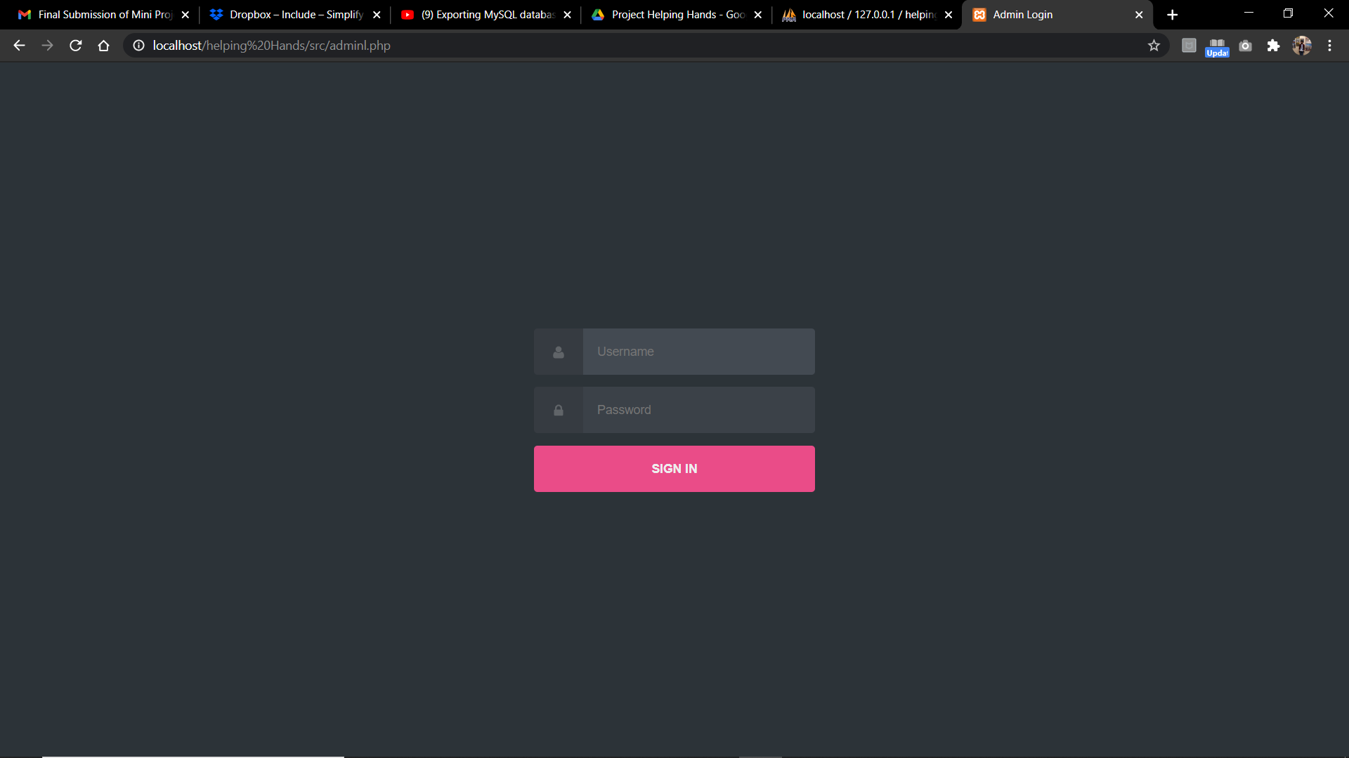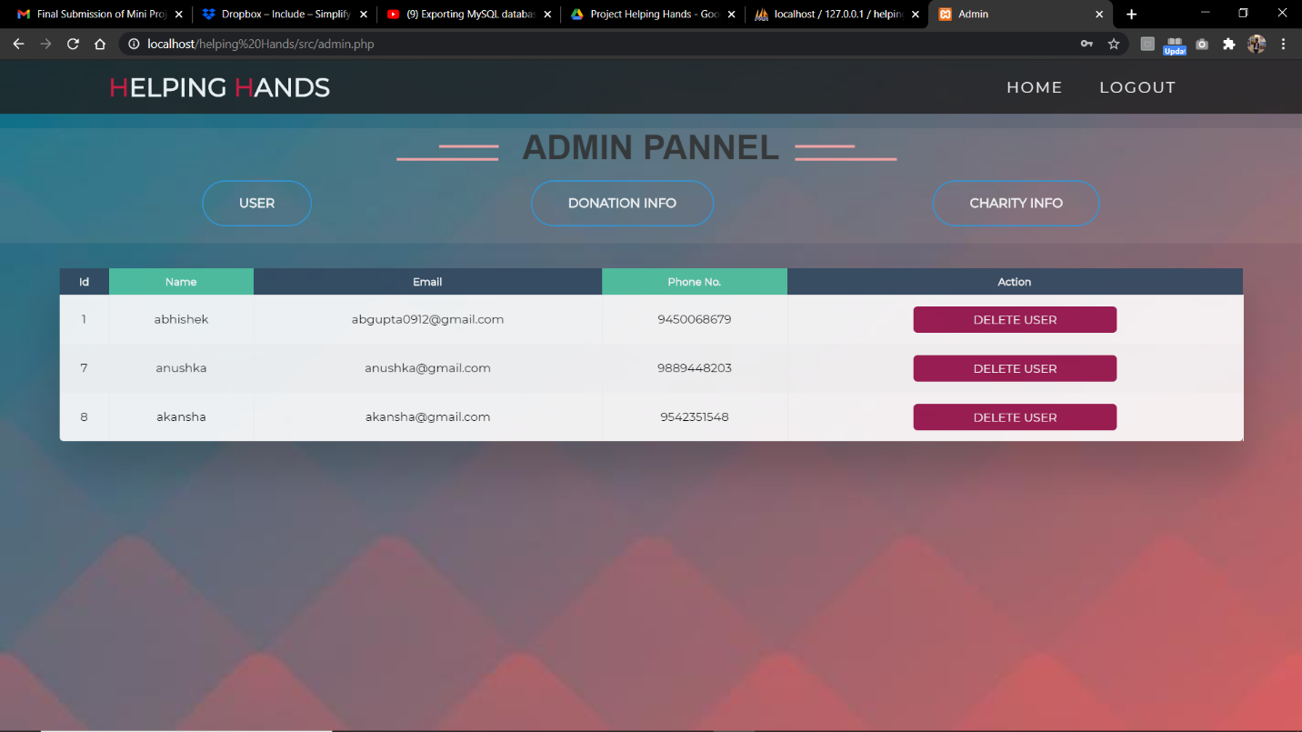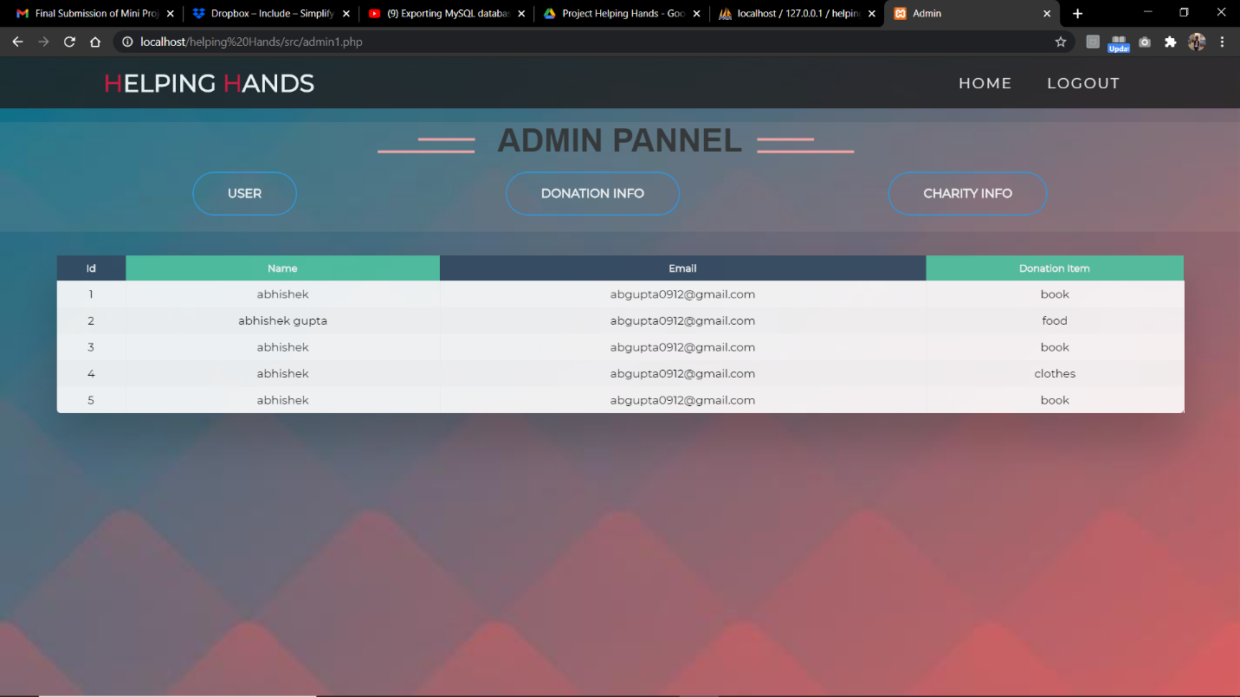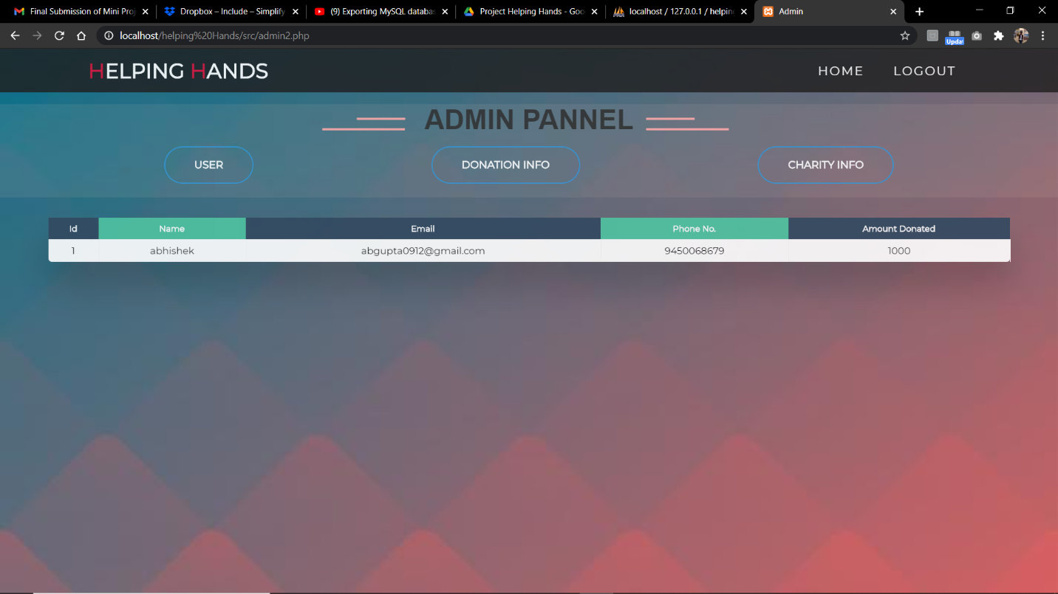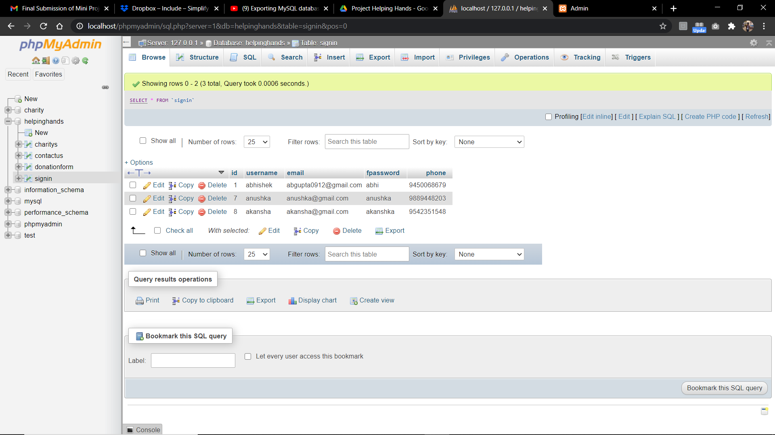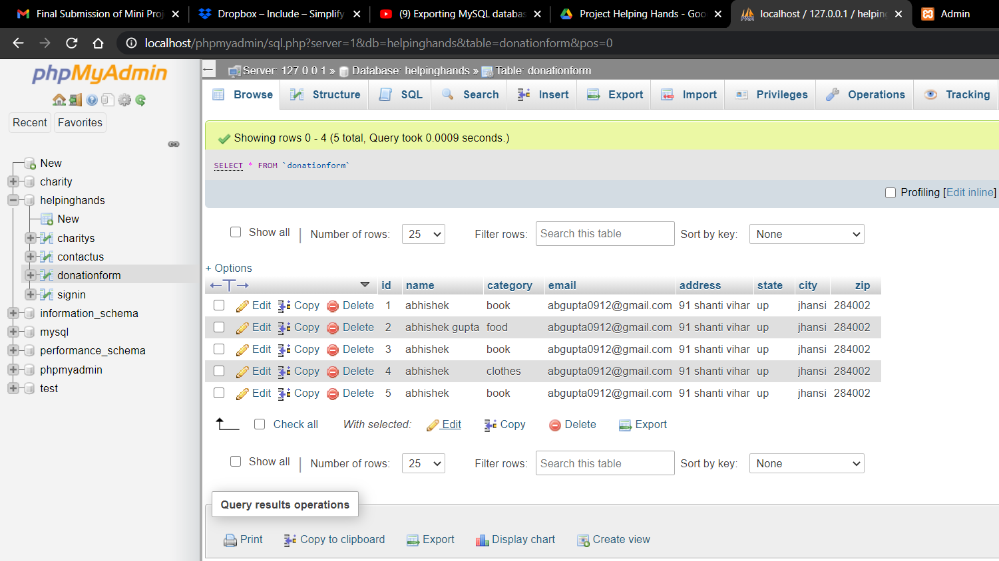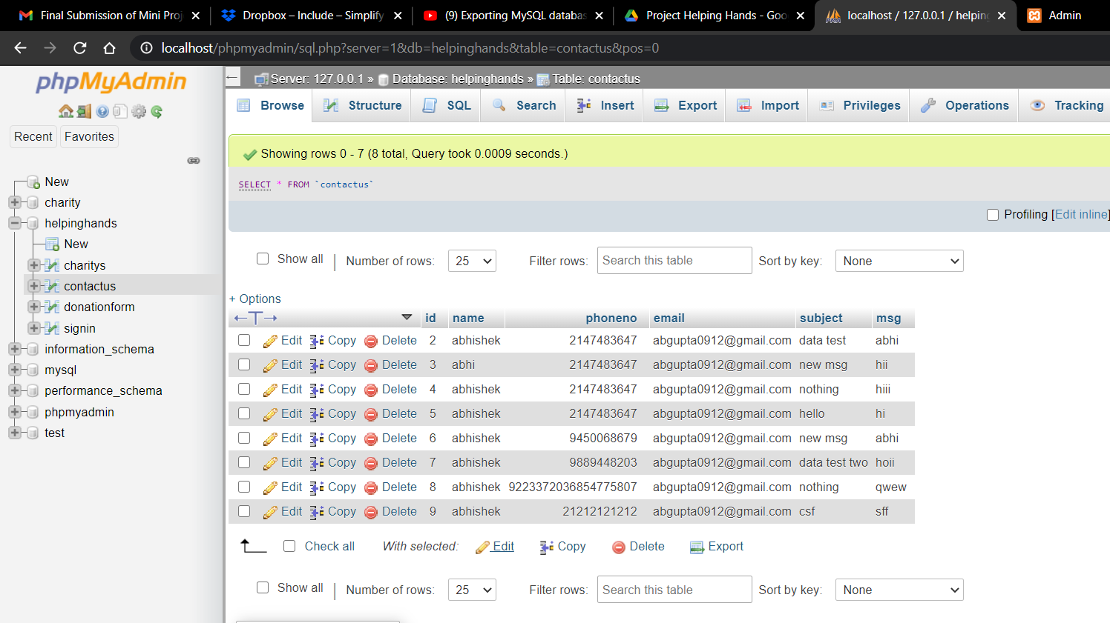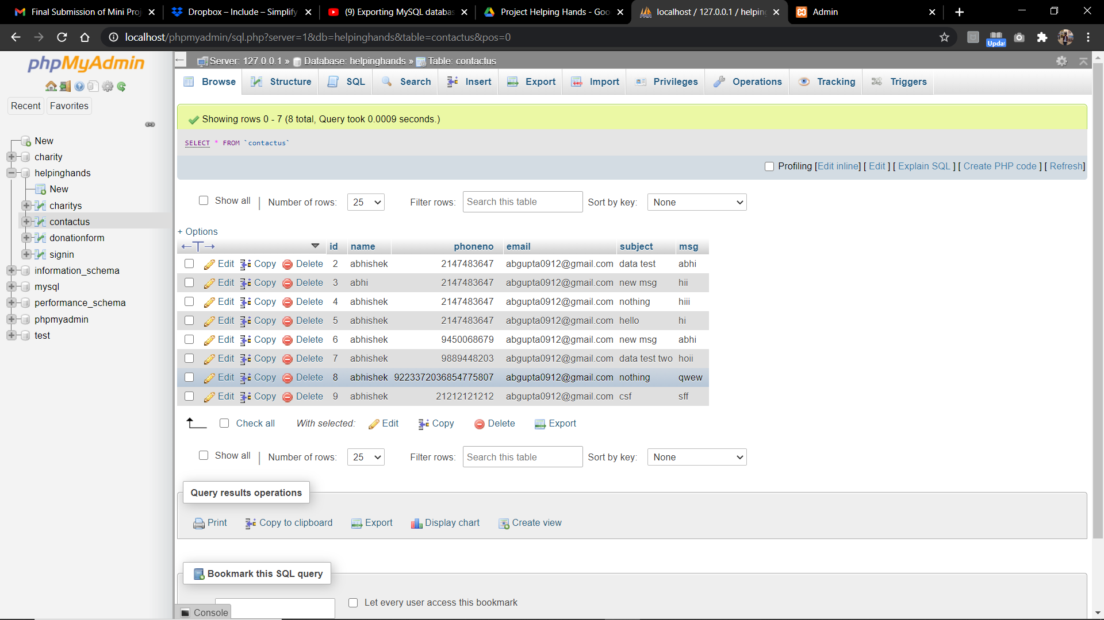

**Implementation and user interface**

**CODE**

INDEX.HTML FILE:

|  |
| --- |
| <!DOCTYPE html> |
|  | <html lang="en"> |
|  | <head> |
|  | <meta charset="UTF-8"> |
|  | <meta name="viewport" content="width=device-width, initial-scale=1.0"> |
|  | <link rel="stylesheet" href="style.css"> |
|  | <title>Helping Hands</title> |
|  | </head> |
|  | <body> |
|  |  |
|  | <section id="header"> |
|  | <div class="header container"> |
|  | <div class="nav-bar"> |
|  | <div class="brand"> |
|  | <a href="../"><h1><span>H</span>elping <span>H</span>ands</h1></a> |
|  | </div> |
|  | <div class="nav-list"> |
|  | <div class="hamburger"><div class="bar"></div></div> |
|  | <ul> |
|  | <li><a href="index.html" data-after="Home">Home</a></li> |
|  |  |
|  | <li><a href="src/charity.php" data-after="Charity">Do Charity</a></li> |
|  | <li><a href="src/login.php" data-after="Login">Login</a></li> |
|  | <li><a href="src/contactus.php" data-after="Contact Us">contact Us</a></li> |
|  | </ul> |
|  | </div> |
|  | </div> |
|  | </div> |
|  | </section> |
|  |  |
|  | <section id="hero"> |
|  | <div class="hero container"> |
|  | <div> |
|  | <h1>Small Effort<span></span></h1> |
|  | <h1>Can Make <span></span></h1> |
|  | <h1>Big Change <span></span></h1> |
|  | <a href="src/donate_us.html" type="button" class="cta">DONATE US</a> |
|  | <h1>Be a part of beautiful world</h1> |
|  | <a href="src/signup.php" type="button" class="cta">Be a Member</a> |
|  |  |
|  | </div> |
|  | </div> |
|  | </section> |
|  |  |
|  | <section id="services"> |
|  | <div class="services container"> |
|  | <div class="service-top"> |
|  | <h1 class="section-title">Insp<span>i</span>ration</h1> |
|  | <p>Volunteers do not necessarily have the time they just have the beautiful heart</p> |
|  | </div> |
|  | <div class="service-bottom"> |
|  | <div class="service-item"> |
|  | <div class="icon"><img src="https://img.icons8.com/bubbles/100/000000/heart.png"/></div> |
|  | <h2>Vision</h2> |
|  | <p>You fight for what’s right, you set that vision of where we could be—and then you go after it yourself.</p> |
|  | </div> |
|  | <div class="service-item"> |
|  | <div class="icon"><img src="https://img.icons8.com/bubbles/100/000000/heart.png"/></div> |
|  | <h2>Mission</h2> |
|  | <p>Change depends on ordinary people who have the courage to say,Enough is enough and no more.</p> |
|  | </div> |
|  | <div class="service-item"> |
|  | <div class="icon"><img src="https://img.icons8.com/bubbles/100/000000/heart.png"/></div> |
|  | <h2>Values</h2> |
|  | <p>Let us remember: One book, one pen, one child, and one teacher can change the world.</p> |
|  | </div> |
|  | <div class="service-item"> |
|  | <div class="icon"><img src="https://img.icons8.com/bubbles/100/000000/heart.png"/></div> |
|  | <h2>Promises</h2> |
|  | <p>We try to come alongside people and interact with our supporters so that they feel, we’re with them.</p> |
|  | </div> |
|  | </div> |
|  | </div> |
|  | </section> |
|  |  |
|  | <section id="projects"> |
|  | <div class="projects container"> |
|  | <div class="projects-header"> |
|  | <h1 class="section-title">Our <span>Projects</span></h1> |
|  | </div> |
|  | <div class="all-projects"> |
|  | <div class="project-item"> |
|  | <div class="project-info"> |
|  | <h1>Send Donation</h1> |
|  | <p>See how can u make a differences in families' lives with just some amout of your love</p> |
|  | </div> |
|  | <div class="project-img"> |
|  | <img src="images/charity-donation.jpg" alt="img"> |
|  | </div> |
|  | </div> |
|  | <div class="project-item"> |
|  | <div class="project-info"> |
|  | <h1>Become volunteers</h1> |
|  | <p>Our support creates empowered communities in the world</p> |
|  | </div> |
|  | <div class="project-img"> |
|  | <img src="images/volunteer.jpg" alt="img"> |
|  | </div> |
|  | </div> |
|  | <div class="project-item"> |
|  | <div class="project-info"> |
|  | <h1>Save the earth</h1> |
|  | <p>Do something crazy to raise money for clean water for childrens</p> |
|  | </div> |
|  | <div class="project-img"> |
|  | <img src="images/save_earth.jpg" alt="img"> |
|  | </div> |
|  | </div> |
|  | <div class="project-item"> |
|  | <div class="project-info"> |
|  | <h1>Sharing</h1> |
|  | <p>Love only grows by sharing. You can only have more for yourself by giving it away to others.</p> |
|  | </div> |
|  | <div class="project-img"> |
|  | <img src="images/sharing-1.jpg" alt="img"> |
|  | </div> |
|  | </div> |
|  | </div> |
|  | </div> |
|  | </section> |
|  |  |
|  | <section id="about"> |
|  | <div class="about container"> |
|  | <div class="col-left"> |
|  | <div class="about-img"> |
|  | <img src="images/about.jpg" alt="img"> |
|  | </div> |
|  | </div> |
|  | <div class="col-right"> |
|  | <h1 class="section-title">About <span>us</span></h1> |
|  | <h2>We're helping hands on</h2> |
|  | <p>NGOs are private nonprofit organizations that pursue activities intended to serve the public |
|  | good. NGOs may provide basic social services, work to relieve suffering, promote the |
|  | interests of the poor, bring citizen concerns to governments, encourage political participation, |
|  | protect the environment, or undertake community development to serve the needs of citizens, |
|  | organizations, or groups in one or more of the communities that the NGO operates. An NGO |
|  | can be any nonprofit organization that is independent from government. |
|  | NGOs can range from large regional, national, or international charities to community-based |
|  | self-help groups. NGOs also include research institutes, churches, professional associations, |
|  | and lobby groups. NGOs typically depend, in whole or in part, on charitable donations and |
|  | voluntary service for support. </p> |
|  | <a href="#" class="cta">Read More</a> |
|  | </div> |
|  | </div> |
|  | </section> |
|  |  |
|  | <section id="footer"> |
|  | <div class="footer container"> |
|  | <div class="brand"><h1><span>H</span>elp <span>W</span>orld</h1></div> |
|  | <h2>Alone we can do so little but together we can do so much</h2> |
|  | <div class="social-icon"> |
|  | <div class="social-item"> |
|  | <a href="#"><img src="https://img.icons8.com/bubbles/100/000000/facebook-new.png"/></a> |
|  | </div> |
|  | <div class="social-item"> |
|  | <a href="#"><img src="https://img.icons8.com/bubbles/100/000000/instagram-new.png"/></a> |
|  | </div> |
|  | <div class="social-item"> |
|  | <a href="#"><img src="https://img.icons8.com/bubbles/100/000000/twitter.png"/></a> |
|  | </div> |
|  | <div class="social-item"> |
|  | <a href="#"><img src="https://img.icons8.com/bubbles/100/000000/behance.png"/></a> |
|  | </div> |
|  | </div> |
|  | </div> |
|  | </section> |
|  |  |
|  | <script src="js/nav.js"></script> |
|  | </body> |
|  | </html> |

JAVASCRIPT FILE:

|  |
| --- |
| const hamburger = document.querySelector('.header .nav-bar .nav-list .hamburger'); |
|  | const mobile_menu = document.querySelector('.header .nav-bar .nav-list ul'); |
|  | const menu_item = document.querySelectorAll('.header .nav-bar .nav-list ul li a'); |
|  | const header = document.querySelector('.header.container'); |
|  |  |
|  | hamburger.addEventListener('click', () => { |
|  | hamburger.classList.toggle('active'); |
|  | mobile_menu.classList.toggle('active'); |
|  | }); |
|  |  |
|  | document.addEventListener('scroll', () => { |
|  | var scroll_position = window.scrollY; |
|  | if (scroll_position > 250) { |
|  | header.style.backgroundColor = '#29323c'; |
|  | } else { |
|  | header.style.backgroundColor = 'transparent'; |
|  | } |
|  | }); |
|  |  |
|  | menu_item.forEach((item) => { |
|  | item.addEventListener('click', () => { |
|  | hamburger.classList.toggle('active'); |
|  | mobile_menu.classList.toggle('active'); |
|  | }); |
|  | }); |

CSS FILE:

|  |
| --- |
| @import 'https://fonts.googleapis.com/css?family=Montserrat:300, 400, 700&display=swap'; |
|  | * { |
|  | padding: 0; |
|  | margin: 0; |
|  | box-sizing: border-box; |
|  | } |
|  | html { |
|  | font-size: 10px; |
|  | font-family: 'Montserrat', sans-serif; |
|  | scroll-behavior: smooth; |
|  | } |
|  | a { |
|  | text-decoration: none; |
|  | } |
|  | .container { |
|  | min-height: 100vh; |
|  | width: 100%; |
|  | display: flex; |
|  | align-items: center; |
|  | justify-content: center; |
|  | } |
|  | img { |
|  | height: 100%; |
|  | width: 100%; |
|  | object-fit: cover; |
|  | } |
|  | p { |
|  | color: black; |
|  | font-size: 1.4rem; |
|  | margin-top: 5px; |
|  | line-height: 2.5rem; |
|  | font-weight: 300; |
|  | letter-spacing: .05rem; |
|  | } |
|  | .section-title { |
|  | font-size: 4rem; |
|  | font-weight: 300; |
|  | color: black; |
|  | margin-bottom: 10px; |
|  | text-transform: uppercase; |
|  | letter-spacing: .2rem; |
|  | text-align: center; |
|  | } |
|  | .section-title span { |
|  | color: crimson; |
|  | } |
|  |  |
|  | .cta { |
|  | display: inline-block; |
|  | padding: 10px 30px; |
|  | color: white; |
|  | background-color: transparent; |
|  | border: 2px solid crimson; |
|  | font-size: 2rem; |
|  | text-transform: uppercase; |
|  | letter-spacing: .1rem; |
|  | margin-top: 30px; |
|  | transition: .3s ease; |
|  | transition-property: background-color, color; |
|  | } |
|  | .cta:hover { |
|  | color: white; |
|  | background-color: crimson; |
|  | } |
|  | .brand h1 { |
|  | font-size: 3rem; |
|  | text-transform: uppercase; |
|  | color: white; |
|  | } |
|  | .brand h1 span { |
|  | color: crimson; |
|  | } |
|  |  |
|  |  |
|  | #header { |
|  | position: fixed; |
|  | z-index: 1000; |
|  | left: 0; |
|  | top: 0; |
|  | width: 100vw; |
|  | height: auto; |
|  | } |
|  | #header .header { |
|  | min-height: 8vh; |
|  | background-color: rgba(31, 30, 30, 0.9); |
|  | transition: .3s ease background-color; |
|  | } |
|  | #header .nav-bar { |
|  | display: flex; |
|  | align-items: center; |
|  | justify-content: space-between; |
|  | width: 100%; |
|  | height: 100%; |
|  | max-width: 1300px; |
|  | padding: 0 10px; |
|  | } |
|  | #header .nav-list ul { |
|  | list-style: none; |
|  | position: absolute; |
|  | background-color: rgb(31, 30, 30); |
|  | width: 100vw; |
|  | height: 100vh; |
|  | left: 100%; |
|  | top: 0; |
|  | display: flex; |
|  | flex-direction: column; |
|  | justify-content: center; |
|  | align-items: center; |
|  | z-index: 1; |
|  | overflow-x: hidden; |
|  | transition: .5s ease left; |
|  | } |
|  | #header .nav-list ul.active { |
|  | left: 0%; |
|  | } |
|  | #header .nav-list ul a { |
|  | font-size: 2.5rem; |
|  | font-weight: 500; |
|  | letter-spacing: .2rem; |
|  | text-decoration: none; |
|  | color: white; |
|  | text-transform: uppercase; |
|  | padding: 20px; |
|  | display: block; |
|  | } |
|  | #header .nav-list ul a::after { |
|  | content: attr(data-after); |
|  | position: absolute; |
|  | top: 50%; |
|  | left: 50%; |
|  | transform: translate(-50%, -50%) scale(0); |
|  | color: rgba(240, 248, 255, 0.021); |
|  | font-size: 13rem; |
|  | letter-spacing: 50px; |
|  | z-index: -1; |
|  | transition: .3s ease letter-spacing; |
|  | } |
|  | #header .nav-list ul li:hover a::after { |
|  | transform: translate(-50%, -50%) scale(1); |
|  | letter-spacing: initial; |
|  | } |
|  | #header .nav-list ul li:hover a { |
|  | color: crimson; |
|  | } |
|  | #header .hamburger { |
|  | height: 60px; |
|  | width: 60px; |
|  | display: inline-block; |
|  | border: 3px solid white; |
|  | border-radius: 50%; |
|  | position: relative; |
|  | display: flex; |
|  | align-items: center; |
|  | justify-content: center; |
|  | z-index: 100; |
|  | cursor: pointer; |
|  | transform: scale(.8); |
|  | margin-right: 20px; |
|  | } |
|  | #header .hamburger:after { |
|  | position: absolute; |
|  | content: ''; |
|  | height: 100%; |
|  | width: 100%; |
|  | border-radius: 50%; |
|  | border: 3px solid white; |
|  | animation: hamburger_puls 1s ease infinite; |
|  | } |
|  | #header .hamburger .bar { |
|  | height: 2px; |
|  | width: 30px; |
|  | position: relative; |
|  | background-color: white; |
|  | z-index: -1; |
|  | } |
|  | #header .hamburger .bar::after, |
|  | #header .hamburger .bar::before { |
|  | content: ''; |
|  | position: absolute; |
|  | height: 100%; |
|  | width: 100%; |
|  | left: 0; |
|  | background-color: white; |
|  | transition: .3s ease; |
|  | transition-property: top, bottom; |
|  | } |
|  | #header .hamburger .bar::after { |
|  | top: 8px; |
|  | } |
|  | #header .hamburger .bar::before { |
|  | bottom: 8px; |
|  | } |
|  | #header .hamburger.active .bar::before { |
|  | bottom: 0; |
|  | } |
|  | #header .hamburger.active .bar::after { |
|  | top: 0; |
|  | } |
|  |  |
|  | #hero { |
|  | background-image: url(images/Donation.png); |
|  | background-size: cover; |
|  | background-position: top center; |
|  | position: relative; |
|  | z-index: 1; |
|  | } |
|  | #hero::after { |
|  | content: ''; |
|  | position: absolute; |
|  | left: 0; |
|  | top: 0; |
|  | height: 100%; |
|  | width: 100%; |
|  | background-color: black; |
|  | opacity: .7; |
|  | z-index: -1; |
|  | } |
|  | #hero .hero { |
|  | max-width: 1200px; |
|  | margin: 0 auto; |
|  | padding: 0 50px; |
|  | justify-content: flex-start; |
|  | } |
|  | #hero h1 { |
|  | display: block; |
|  | width: fit-content; |
|  | font-size: 4rem; |
|  | position: relative; |
|  | color: transparent; |
|  | animation: text_reveal .5s ease forwards; |
|  | animation-delay: 1s; |
|  | } |
|  | #hero h1:nth-child(1) { |
|  | animation-delay: 1s; |
|  | } |
|  | #hero h1:nth-child(2) { |
|  | animation-delay: 2s; |
|  | } |
|  | #hero h1:nth-child(3) { |
|  | animation: text_reveal_name .5s ease forwards; |
|  | animation-delay: 3s; |
|  | } |
|  | #hero h1 span { |
|  | position: absolute; |
|  | top: 0; |
|  | left: 0; |
|  | height: 100%; |
|  | width: 0; |
|  | background-color: crimson; |
|  | animation: text_reveal_box 1s ease; |
|  | animation-delay: .5s; |
|  | } |
|  | #hero h1:nth-child(1) span { |
|  | animation-delay: .5s; |
|  | } |
|  | #hero h1:nth-child(2) span { |
|  | animation-delay: 1.5s; |
|  | } |
|  | #hero h1:nth-child(3) span { |
|  | animation-delay: 2.5s; |
|  | } |
|  |  |
|  |  |
|  | #services .services { |
|  | flex-direction: column; |
|  | text-align: center; |
|  | max-width: 1500px; |
|  | margin: 0 auto; |
|  | padding: 100px 0; |
|  | } |
|  | #services .service-top { |
|  | max-width: 500px; |
|  | margin: 0 auto; |
|  | } |
|  | #services .service-bottom { |
|  | display: flex; |
|  | align-items: center; |
|  | justify-content: center; |
|  | flex-wrap: wrap; |
|  | margin-top: 50px; |
|  | } |
|  | #services .service-item { |
|  | flex-basis: 80%; |
|  | display: flex; |
|  | align-items: flex-start; |
|  | justify-content: center; |
|  | flex-direction: column; |
|  | padding: 30px; |
|  | border-radius: 10px; |
|  | background-image: url(images/customers.jpg); |
|  | background-size: cover; |
|  | margin: 10px 5%; |
|  | position: relative; |
|  | z-index: 1; |
|  | overflow: hidden; |
|  | } |
|  | #services .service-item::after { |
|  | content: ''; |
|  | position: absolute; |
|  | left: 0; |
|  | top: 0; |
|  | height: 100%; |
|  | width: 100%; |
|  | opacity: .9; |
|  | z-index: -1; |
|  | } |
|  | #services .service-bottom .icon { |
|  | height: 80px; |
|  | width: 80px; |
|  | margin-bottom: 20px; |
|  | } |
|  | #services .service-item h2 { |
|  | font-size: 2rem; |
|  | color: red; |
|  | margin-bottom: 10px; |
|  | text-transform: uppercase; |
|  | } |
|  | #services .service-item p { |
|  | color: white; |
|  | text-align: left; |
|  | } |
|  |  |
|  | #projects .projects { |
|  | flex-direction: column; |
|  | max-width: 1200px; |
|  | margin: 0 auto; |
|  | padding: 100px 0; |
|  | } |
|  | #projects .projects-header h1 { |
|  | margin-bottom: 50px; |
|  | } |
|  | #projects .all-projects { |
|  | display: flex; |
|  | align-items: center; |
|  | justify-content: center; |
|  | flex-direction: column; |
|  | } |
|  | #projects .project-item { |
|  | display: flex; |
|  | align-items: center; |
|  | justify-content: center; |
|  | flex-direction: column; |
|  | width: 50%; |
|  | margin: 20px auto; |
|  | overflow: hidden; |
|  | border-radius: 10px; |
|  | } |
|  | #projects .project-info { |
|  | padding: 30px; |
|  | flex-basis: 50%; |
|  | height: 50%; |
|  | display: flex; |
|  | align-items: flex-start; |
|  | justify-content: center; |
|  | flex-direction: column; |
|  | background-image: linear-gradient(60deg, #29323c 0%, #485563 100%); |
|  | color: white; |
|  | } |
|  | #projects .project-info h1 { |
|  | font-size: 4rem; |
|  | font-weight: 500; |
|  | } |
|  | #projects .project-info h2 { |
|  | font-size: 1.8rem; |
|  | font-weight: 500; |
|  | margin-top: 10px; |
|  | } |
|  | #projects .project-info p { |
|  | color: white; |
|  | } |
|  | #projects .project-img { |
|  | flex-basis: 50%; |
|  | height: 300px; |
|  | overflow: hidden; |
|  | position: relative; |
|  | } |
|  | #projects .project-img:after { |
|  | content: ''; |
|  | position: absolute; |
|  | left: 0; |
|  | top: 0; |
|  | height: 70%; |
|  | width: 70%; |
|  | opacity: .7; |
|  | } |
|  | #projects .project-img img { |
|  | transition: .3s ease transform; |
|  | } |
|  | #projects .project-item:hover .project-img img { |
|  | transform: scale(1.1); |
|  | } |
|  |  |
|  | #about .about { |
|  | flex-direction: column-reverse; |
|  | text-align: center; |
|  | max-width: 1200px; |
|  | margin: 0 auto; |
|  | padding: 100px 20px; |
|  | } |
|  | #about .col-left { |
|  | width: 250px; |
|  | height: 360px; |
|  | } |
|  | #about .col-right { |
|  | width: 100%; |
|  | } |
|  | #about .col-right h2 { |
|  | font-size: 1.8rem; |
|  | font-weight: 500; |
|  | letter-spacing: .2rem; |
|  | margin-bottom: 10px; |
|  | } |
|  | #about .col-right p { |
|  | margin-bottom: 20px; |
|  | } |
|  | #about .col-right .cta { |
|  | color: black; |
|  | margin-bottom: 50px; |
|  | padding: 10px 20px; |
|  | font-size: 2rem; |
|  | } |
|  | #about .col-left .about-img { |
|  | height: 100%; |
|  | width: 100%; |
|  | position: relative; |
|  | border: 10px solid white; |
|  | } |
|  | #about .col-left .about-img::after { |
|  | content: ''; |
|  | position: absolute; |
|  | left: -33px; |
|  | top: 19px; |
|  | height: 98%; |
|  | width: 98%; |
|  | border: 7px solid crimson; |
|  | z-index: -1; |
|  | } |
|  |  |
|  | #contact .contact { |
|  | flex-direction: column; |
|  | max-width: 1200px; |
|  | margin: 0 auto; |
|  | } |
|  | #contact .contact-items { |
|  | width: 400px; |
|  | } |
|  | #contact .contact-item { |
|  | width: 80%; |
|  | padding: 20px; |
|  | text-align: center; |
|  | border-radius: 10px; |
|  | padding: 30px; |
|  | margin: 30px; |
|  | display: flex; |
|  | justify-content: center; |
|  | align-items: center; |
|  | flex-direction: column; |
|  | box-shadow: 0px 0px 18px 0 #0000002c; |
|  | transition: .3s ease box-shadow; |
|  | } |
|  | #contact .contact-item:hover { |
|  | box-shadow: 0px 0px 5px 0 #0000002c; |
|  | } |
|  | #contact .icon { |
|  | width: 70px; |
|  | margin: 0 auto; |
|  | margin-bottom: 10px; |
|  | } |
|  | #contact .contact-info h1 { |
|  | font-size: 2.5rem; |
|  | font-weight: 500; |
|  | margin-bottom: 5px; |
|  | } |
|  | #contact .contact-info h2 { |
|  | font-size: 1.3rem; |
|  | line-height: 2rem; |
|  | font-weight: 500; |
|  | } |
|  |  |
|  | #footer { |
|  | background-image: linear-gradient(60deg, #29323c 0%, #485563 100%); |
|  | } |
|  | #footer .footer { |
|  | min-height: 200px; |
|  | flex-direction: column; |
|  | padding-top: 50px; |
|  | padding-bottom: 10px; |
|  | } |
|  | #footer h2 { |
|  | color: white; |
|  | font-weight: 500; |
|  | font-size: 1.8rem; |
|  | letter-spacing: .1rem; |
|  | margin-top: 10px; |
|  | margin-bottom: 10px; |
|  | } |
|  | #footer .social-icon { |
|  | display: flex; |
|  | margin-bottom: 30px; |
|  | } |
|  | #footer .social-item { |
|  | height: 50px; |
|  | width: 50px; |
|  | margin: 0 5px; |
|  | } |
|  | #footer .social-item img { |
|  | filter: grayscale(1); |
|  | transition: .3s ease filter; |
|  | } |
|  | #footer .social-item:hover img { |
|  | filter: grayscale(0); |
|  | } |
|  | #footer p { |
|  | color: white; |
|  | font-size: 1.3rem; |
|  | } |
|  |  |
|  | @keyframes hamburger_puls { |
|  | 0% { |
|  | opacity: 1; |
|  | transform: scale(1); |
|  | } |
|  | 100% { |
|  | opacity: 0; |
|  | transform: scale(1.4); |
|  | } |
|  | } |
|  | @keyframes text_reveal_box { |
|  | 50% { |
|  | width: 100%; |
|  | left: 0; |
|  | } |
|  | 100% { |
|  | width: 0; |
|  | left: 100%; |
|  | } |
|  | } |
|  | @keyframes text_reveal { |
|  | 100% { |
|  | color: white; |
|  | } |
|  | } |
|  | @keyframes text_reveal_name { |
|  | 100% { |
|  | color: crimson; |
|  | font-weight: 500; |
|  | } |
|  | } |
|  |  |
|  | @media only screen and (min-width: 768px) { |
|  | .cta { |
|  | font-size: 2.5rem; |
|  | padding: 20px 60px; |
|  | } |
|  | h1.section-title { |
|  | font-size: 6rem; |
|  | } |
|  |  |
|  |  |
|  | #hero h1 { |
|  | font-size: 7rem; |
|  | } |
|  |  |
|  | #services .service-bottom .service-item { |
|  | flex-basis: 45%; |
|  | margin: 2.5%; |
|  | } |
|  |  |
|  | #projects .project-item { |
|  | flex-direction: row; |
|  | } |
|  | #projects .project-item:nth-child(even) { |
|  | flex-direction: row-reverse; |
|  | } |
|  | #projects .project-item { |
|  | height: 400px; |
|  | margin: 0; |
|  | width: 100%; |
|  | border-radius: 0; |
|  | } |
|  | #projects .all-projects .project-info { |
|  | height: 100%; |
|  | } |
|  | #projects .all-projects .project-img { |
|  | height: 100%; |
|  | } |
|  |  |
|  | #about .about { |
|  | flex-direction: row; |
|  | } |
|  | #about .col-left { |
|  | width: 600px; |
|  | height: 400px; |
|  | padding-left: 60px; |
|  | } |
|  | #about .about .col-left .about-img::after { |
|  | left: -45px; |
|  | top: 34px; |
|  | height: 98%; |
|  | width: 98%; |
|  | border: 10px solid crimson; |
|  | } |
|  | #about .col-right { |
|  | text-align: left; |
|  | padding: 30px; |
|  | } |
|  | #about .col-right h1 { |
|  | text-align: left; |
|  | } |
|  |  |
|  | #contact .contact { |
|  | flex-direction: column; |
|  | padding: 100px 0; |
|  | align-items: center; |
|  | justify-content: center; |
|  | min-width: 20vh; |
|  | } |
|  | #contact .contact-items { |
|  | width: 100%; |
|  | display: flex; |
|  | flex-direction: row; |
|  | justify-content: space-evenly; |
|  | margin: 0; |
|  | } |
|  | #contact .contact-item { |
|  | width: 30%; |
|  | margin: 0; |
|  | flex-direction: row; |
|  | } |
|  | #contact .contact-item .icon { |
|  | height: 100px; |
|  | width: 100px; |
|  | } |
|  | #contact .contact-item .icon img { |
|  | object-fit: contain; |
|  | } |
|  | #contact .contact-item .contact-info { |
|  | width: 100%; |
|  | text-align: left; |
|  | padding-left: 20px; |
|  | } |
|  |  |
|  | } |
|  |  |
|  | @media only screen and (min-width: 1200px) { |
|  |  |
|  | #header .hamburger { |
|  | display: none; |
|  | } |
|  | #header .nav-list ul { |
|  | position: initial; |
|  | display: block; |
|  | height: auto; |
|  | width: fit-content; |
|  | background-color: transparent; |
|  | } |
|  | #header .nav-list ul li { |
|  | display: inline-block; |
|  | } |
|  | #header .nav-list ul li a { |
|  | font-size: 1.8rem; |
|  | } |
|  | #header .nav-list ul a:after { |
|  | display: none; |
|  | } |
|  |  |
|  |  |
|  | #services .service-bottom .service-item { |
|  | flex-basis: 22%; |
|  | margin: 1.5%; |
|  | } |
|  | } |

DONATION FORM PHP FILE:

|  |
| --- |
| <?php |
|  | require_once("include\connection.php"); |
|  | $NameError=""; |
|  | $AddressError=""; |
|  | $CityError=""; |
|  | $StateError=""; |
|  | $ZipError=""; |
|  | $categoryerror=""; |
|  | if(isset($_POST["submit"])){ |
|  | if(!empty($_POST["firstname"])) |
|  | { |
|  | if(!preg_match("/^[A-Za-z\. ]*$/",$_POST["firstname"])){ |
|  | $NameError=" * Only Letters and white sapace are allowed"; |
|  | } |
|  | } |
|  | if(!empty($_POST["address"])) |
|  | { |
|  | if(!preg_match("/^[A-Za-z0-9\, ]*$/",$_POST["address"])){ |
|  | $AddressError=" * Only Letters and white sapace are allowed "; |
|  | } |
|  | } |
|  | if(!empty($_POST["city"])) |
|  | { |
|  | if(!preg_match("/^[A-Za-z\ ]*$/",$_POST["city"])){ |
|  | $CityError=" * Only Letters and white sapace are allowed"; |
|  | } |
|  | } |
|  |  |
|  | if(!empty($_POST["state"])) |
|  | { |
|  | if(!preg_match("/^[A-Za-z\ ]*$/",$_POST["state"])){ |
|  | $StateError=" * Only Letters and white sapace are allowed"; |
|  | } |
|  | } |
|  | if(!empty($_POST["zip"])) |
|  | { |
|  | if(!preg_match("/^[0-9 ]{6}$/",$_POST["zip"])){ |
|  | $ZipError=" * Enter 6 Digit Code"; |
|  | } |
|  | } |
|  | if(!empty($_POST["category"])){ |
|  | $category=strtolower($_POST["category"]); |
|  | if($category!="book" || $category!="food" || $category!="clothes"){ |
|  | $categoryerror=" * Only Books Food Clothes can be donated..."; |
|  | } |
|  |  |
|  | } |
|  | } |
|  | if(!empty($_POST["firstname"]) |
|  | &&!empty($_POST["address"]) |
|  | &&!empty($_POST["city"]) |
|  | &&!empty($_POST["state"]) |
|  | &&!empty($_POST["email"]) |
|  | &&!empty($_POST["zip"]) |
|  | &&!empty($_POST["category"])){ |
|  | $category=strtolower($_POST["category"]); |
|  | if((preg_match("/^[A-Za-z\. ]*$/",$_POST["firstname"])==true) |
|  | &&(preg_match("/^[A-Za-z0-9\, ]*$/",$_POST["address"])==true) |
|  | &&(preg_match("/^[A-Za-z\ ]*$/",$_POST["city"])==true) |
|  | &&(preg_match("/^[0-9 ]{6}$/",$_POST["zip"])==true) |
|  | &&(preg_match("/^[A-Za-z\ ]*$/",$_POST["state"])) |
|  | &&($category!="book" || $category!="food" || $category!="clothes" || $category!="clothe" || $category!="books")) |
|  | { |
|  | $emailto="abgupta0912@gmail.com"; |
|  | $subject="Donation item received"; |
|  | $message="Person Name : ".$_POST["firstname"]. |
|  | " \r\nPerson Address ".$_POST["address"]." ,".$_POST["city"]." ,".$_POST["state"]." (".$_POST["zip"].")". |
|  | " \r\nPerson Email :".$_POST["email"]. |
|  | "\r\nDonated item ".$category; |
|  | $header="From: abgupta0912@gmail.com"; |
|  | if(mail($emailto,$subject,$message,$header)){ |
|  | $name=$_POST["firstname"]; |
|  | $address=$_POST["address"]; |
|  | $email=$_POST["email"]; |
|  | $city=$_POST["city"]; |
|  | $state=$_POST["state"]; |
|  | $zip=$_POST["zip"]; |
|  | $connction; |
|  | $sql="insert into donationform(name,category,email,address,state,city,zip) |
|  | values(:namE,:categorY,:emaiL,:addresS,:statE,:citY,:ziP)"; |
|  | $stmt=$connction->prepare($sql); |
|  | $stmt->bindValue(':namE',$name); |
|  | $stmt->bindValue(':addresS',$address); |
|  | $stmt->bindValue(':emaiL',$email); |
|  | $stmt->bindValue(':statE',$state); |
|  | $stmt->bindValue(':ziP',$zip); |
|  | $stmt->bindValue(':citY',$city); |
|  | $stmt->bindValue(':categorY',$category); |
|  | $Execute= $stmt->execute(); |
|  |  |
|  |  |
|  | } |
|  |  |
|  |  |
|  | } |
|  | } |
|  | ?> |
|  |  |
|  |  |
|  | <!DOCTYPE html> |
|  | <html> |
|  | <head> |
|  | <meta name="viewport" content="width=device-width, initial-scale=1"> |
|  | <link rel="stylesheet" href="https://cdnjs.cloudflare.com/ajax/libs/font-awesome/4.7.0/css/font-awesome.min.css"> |
|  | <link rel="stylesheet" href="../css/userform.css"> |
|  | <title>Donation Form</title> |
|  | </head> |
|  | <body> |
|  | <section id="header"> |
|  | <div class="header container"> |
|  | <div class="nav-bar"> |
|  | <div class="brand"> |
|  | <a href="../index.html"><h1><span>H</span>elping <span>H</span>ands</h1></a> |
|  | </div> |
|  | <div class="nav-list"> |
|  | <div class="hamburger"><div class="bar"></div></div> |
|  | <ul> |
|  | <li><a href="../index.html" data-after="Home">Home</a></li> |
|  |  |
|  | <li><a href="charity.php" data-after="About">Do Charity</a></li> |
|  | <li><a href="contactus.php" data-after="About">contact Us</a></li> |
|  | </ul> |
|  | </div> |
|  | </div> |
|  | </div> |
|  | </section> |
|  |  |
|  | <h2>Don't turn away, <span style="color: crimson; font-size: 3.5rem;">G</span>ive today! <br> <span style="color: crimson; font-size: 3.5rem;">B</span>e the change.</h2> |
|  | <div class="row"> |
|  | <div class="col-50"> |
|  | <div class="container1"> |
|  | <form action="DontionForm.php" method="POST"> |
|  |  |
|  | <div class="row"> |
|  | <div class="col-50"> |
|  | <h3>Donar Info</h3> |
|  | <label for="fname"><i class="fa fa-user"></i> Full Name</label> |
|  | <input type="text" id="fname" name="firstname" placeholder="abhi gupta <?php echo $NameError;?>" required> |
|  | <label for="fname"><i class="fa fa-check-circle"></i> Category</label> |
|  | <input type="text" id="fname" name="category" placeholder="Books Clothes Food <?php echo $categoryerror;?>" required> |
|  | <label for="email"><i class="fa fa-envelope"></i> Email</label> |
|  | <input type="text" id="email" name="email" placeholder="xyz@example.com " required> |
|  | <label for="adr"><i class="fa fa-address-card-o"></i> Address</label> |
|  | <input type="text" id="adr" name="address" placeholder="132, shanti niwas <?php echo $AddressError;?>" required > |
|  | <label for="city"><i class="fa fa-institution"></i> City</label> |
|  | <input type="text" id="city" name="city" placeholder="Mathura <?php echo $CityError;?>" required > |
|  |  |
|  | <div class="row"> |
|  | <div class="col-50"> |
|  | <label for="state">State</label> |
|  | <input type="text" id="state" name="state" placeholder="UP.. <?php echo $StateError;?>"required> |
|  | </div> |
|  | <div class="col-50"> |
|  | <label for="zip">Zip</label> |
|  | <input type="text" id="zip" name="zip" placeholder="1234567 <?php echo $ZipError;?>" required> |
|  | </div> |
|  | </div> |
|  | </div> |
|  | </div> |
|  | <input type="submit" value="Submit Details" name="submit" class="btn"> |
|  | </form> |
|  | </div> |
|  | </div> |
|  |  |
|  | </div> |
|  | <script src="../js/nav.js"></script> |
|  | </body> |
|  | </html> |

ACCOUNT HOME PHP FILE:

|  |
| --- |
| <!DOCTYPE html> |
|  | <html lang="en"> |
|  | <head> |
|  | <meta charset="UTF-8"> |
|  | <meta name="viewport" content="width=device-width, initial-scale=1.0"> |
|  | <link rel="stylesheet" href="https://stackpath.bootstrapcdn.com/font-awesome/4.7.0/css/font-awesome.min.css" > |
|  | <link rel="stylesheet" href="../style.css"> |
|  | <title>Helping Hands</title> |
|  | </head> |
|  | <body> |
|  |  |
|  | <section id="header"> |
|  | <div class="header container" > |
|  | <div class="nav-bar"> |
|  | <div class="brand"> |
|  | <a href="accounthome.php"><h1><span>H</span>elping <span>H</span>ands</h1></a> |
|  | </div> |
|  | <div class="nav-list"> |
|  | <div class="hamburger" ><div class="bar"></div></div> |
|  | <ul> |
|  | <li><a href="accounthome.php" data-after="Home">Home</a></li> |
|  | <li><a href="charity.php" data-after="Charity">Do Charity</a></li> |
|  | <li><a href="profile.php" data-after="Profile">Profile</a></li> |
|  | <li><a href="contactus.php" data-after="Contact Us">contact Us</a></li> |
|  | <li><a href="logout.php" data-after="Log Out">LogOut</a></li> |
|  | </ul> |
|  | </div> |
|  | </div> |
|  | </div> |
|  | </section> |
|  |  |
|  |  |
|  |  |
|  | <section id="hero"> |
|  | <div class="hero container"> |
|  | <div> |
|  | <h1>Small Effort<span></span></h1> |
|  | <h1>Can Make <span></span></h1> |
|  | <h1>Big Change <span></span></h1> |
|  | <a href="userdonate.html" type="button" class="cta">DONATE US</a> |
|  | <h1>Be a part of beautiful world</h1> |
|  | <a href="#" type="button" class="cta">Welcome</a> |
|  | </div> |
|  | </div> |
|  | </section> |
|  |  |
|  |  |
|  |  |
|  | <section id="services"> |
|  | <div class="services container"> |
|  | <div class="service-top"> |
|  | <h1 class="section-title">Insp<span>i</span>ration</h1> |
|  | <p>Volunteers do not necessarily have the time they just have the beautiful heart</p> |
|  | </div> |
|  | <div class="service-bottom"> |
|  | <div class="service-item"> |
|  | <div class="icon"><img src="https://img.icons8.com/bubbles/100/000000/heart.png"/></div> |
|  | <h2>Vision</h2> |
|  | <p>You fight for what’s right, you set that vision of where we could be—and then you go after it yourself.</p> |
|  | </div> |
|  | <div class="service-item"> |
|  | <div class="icon"><img src="https://img.icons8.com/bubbles/100/000000/heart.png"/></div> |
|  | <h2>Mission</h2> |
|  | <p>Change depends on ordinary people who have the courage to say,Enough is enough and no more.</p> |
|  | </div> |
|  | <div class="service-item"> |
|  | <div class="icon"><img src="https://img.icons8.com/bubbles/100/000000/heart.png"/></div> |
|  | <h2>Values</h2> |
|  | <p>Let us remember: One book, one pen, one child, and one teacher can change the world.</p> |
|  | </div> |
|  | <div class="service-item"> |
|  | <div class="icon"><img src="https://img.icons8.com/bubbles/100/000000/heart.png"/></div> |
|  | <h2>Promises</h2> |
|  | <p>We try to come alongside people and interact with our supporters so that they feel, we’re with them.</p> |
|  | </div> |
|  | </div> |
|  | </div> |
|  | </section> |
|  |  |
|  | <section id="projects"> |
|  | <div class="projects container"> |
|  | <div class="projects-header"> |
|  | <h1 class="section-title">Our <span>Projects</span></h1> |
|  | </div> |
|  | <div class="all-projects"> |
|  | <div class="project-item"> |
|  | <div class="project-info"> |
|  | <h1>Send Donation</h1> |
|  | <p>See how can u make a differences in families' lives with just some amout of your love</p> |
|  | </div> |
|  | <div class="project-img"> |
|  | <img src="../images/charity-donation.jpg" alt="img"> |
|  | </div> |
|  | </div> |
|  | <div class="project-item"> |
|  | <div class="project-info"> |
|  | <h1>Become volunteers</h1> |
|  | <p>Our support creates empowered communities in the world</p> |
|  | </div> |
|  | <div class="project-img"> |
|  | <img src="../images/volunteer.jpg" alt="img"> |
|  | </div> |
|  | </div> |
|  | <div class="project-item"> |
|  | <div class="project-info"> |
|  | <h1>Save the earth</h1> |
|  | <p>Do something crazy to raise money for clean water for childrens</p> |
|  | </div> |
|  | <div class="project-img"> |
|  | <img src="../images/save_earth.jpg" alt="img"> |
|  | </div> |
|  | </div> |
|  | <div class="project-item"> |
|  | <div class="project-info"> |
|  | <h1>Sharing</h1> |
|  | <p>Love only grows by sharing. You can only have more for yourself by giving it away to others.</p> |
|  | </div> |
|  | <div class="project-img"> |
|  | <img src="../images/sharing-1.jpg" alt="img"> |
|  | </div> |
|  | </div> |
|  | </div> |
|  | </div> |
|  | </section> |
|  |  |
|  | <section id="about"> |
|  | <div class="about container"> |
|  | <div class="col-left"> |
|  | <div class="about-img"> |
|  | <img src="../images/about.jpg" alt="img"> |
|  | </div> |
|  | </div> |
|  | <div class="col-right"> |
|  | <h1 class="section-title">About <span>us</span></h1> |
|  | <h2>We're helping hands on</h2> |
|  | <p>NGOs are private nonprofit organizations that pursue activities intended to serve the public |
|  | good. NGOs may provide basic social services, work to relieve suffering, promote the |
|  | interests of the poor, bring citizen concerns to governments, encourage political participation, |
|  | protect the environment, or undertake community development to serve the needs of citizens, |
|  | organizations, or groups in one or more of the communities that the NGO operates. An NGO |
|  | can be any nonprofit organization that is independent from government. |
|  | NGOs can range from large regional, national, or international charities to community-based |
|  | self-help groups. NGOs also include research institutes, churches, professional associations, |
|  | and lobby groups. NGOs typically depend, in whole or in part, on charitable donations and |
|  | voluntary service for support. </p> |
|  | <a href="#" class="cta">Read More</a> |
|  | </div> |
|  | </div> |
|  | </section> |
|  |  |
|  | <section id="footer"> |
|  | <div class="footer container"> |
|  | <div class="brand"><h1><span>H</span>elp <span>W</span>orld</h1></div> |
|  | <h2>Alone we can do so little but together we can do so much</h2> |
|  | <div class="social-icon"> |
|  | <div class="social-item"> |
|  | <a href="#"><img src="https://img.icons8.com/bubbles/100/000000/facebook-new.png"/></a> |
|  | </div> |
|  | <div class="social-item"> |
|  | <a href="#"><img src="https://img.icons8.com/bubbles/100/000000/instagram-new.png"/></a> |
|  | </div> |
|  | <div class="social-item"> |
|  | <a href="#"><img src="https://img.icons8.com/bubbles/100/000000/twitter.png"/></a> |
|  | </div> |
|  | <div class="social-item"> |
|  | <a href="#"><img src="https://img.icons8.com/bubbles/100/000000/behance.png"/></a> |
|  | </div> |
|  | </div> |
|  | </div> |
|  | </section> |
|  | <script src="../js/nav.js"></script> |
|  |  |
|  | </body> |
|  | </html> |

ADMIN PHP FILE:

|  |
| --- |
| <?php require_once('include/connection.php'); |
|  | if(isset($_GET['delete'])){ |
|  | $did=$_GET['delete']; |
|  | $execute=$connction->query("DELETE FROM signin WHERE id='$did'"); |
|  | if($execute){ |
|  | header("Location:admin.php"); |
|  | } |
|  | else{ |
|  | header("Location:admin.php"); |
|  | } |
|  | } |
|  |  |
|  | ?> |
|  | <!DOCTYPE html> |
|  | <html lang="en"> |
|  | <head> |
|  | <meta charset="UTF-8"> |
|  | <meta name="viewport" content="width=device-width, initial-scale=1.0"> |
|  | <title>Admin</title> |
|  | <link rel="stylesheet" href="../css/admin.css"> |
|  | </head> |
|  | <body> |
|  | <section id="header"> |
|  | <div class="header container"> |
|  | <div class="nav-bar"> |
|  | <div class="brand"> |
|  | <a href="accounthome.php"><h1><span>H</span>elping <span>H</span>ands</h1></a> |
|  | </div> |
|  | <div class="nav-list"> |
|  | <div class="hamburger"><div class="bar"></div></div> |
|  | <ul> |
|  | <li><a href="../index.html" data-after="Home">Home</a></li> |
|  | <li><a href="logout.php" data-after="logout">LogOut</a></li> |
|  | </ul> |
|  | </div> |
|  | </div> |
|  | </div> |
|  | </section> |
|  | <div class="buttons" style="margin-top: 80px;"> |
|  | <div class="head"> |
|  | <span class="top right"></span> |
|  | <span class="top left"></span> |
|  | <h1>Admin Pannel</h1> |
|  | <span class="bottom right"></span> |
|  | <span class="bottom left"></span> |
|  | </div> |
|  | <div class="button"> |
|  | <button class="btn btns" onclick="window.location.href='admin.php'">User</button> |
|  | <button class="btn btns " onclick="window.location.href='admin1.php'">Donation Info</button> |
|  | <Button class="btn btns" onclick="window.location.href='admin2.php'">Charity Info</Button> |
|  | </div> |
|  | </div> |
|  |  |
|  | <div class="table-wrapper" style="margin-top: 30px;"> |
|  | <table class="fl-table"> |
|  | <thead> |
|  | <tr> |
|  | <th>Id</th> |
|  | <th>Name</th> |
|  | <th>Email</th> |
|  | <th>Phone No.</th> |
|  | <th>Action</th> |
|  | </tr> |
|  | </thead> |
|  | <tbody> |
|  |  |
|  | <?php |
|  | $connction; |
|  | $sql="SELECT * FROM signin"; |
|  | $stmt=$connction->query($sql); |
|  | while($datarow=$stmt->fetch()){ |
|  | $id=$datarow['id']; |
|  | $user=$datarow['username']; |
|  | $email=$datarow['email']; |
|  | $phone=$datarow['phone']; |
|  |  |
|  |  |
|  | ?> |
|  | <tr> |
|  | <td><?php echo $id;?></td> |
|  | <td><?php echo $user;?></td> |
|  | <td><?php echo $email;?></td> |
|  | <td><?php echo $phone;?></td> |
|  | <!-- <td> |
|  | <input type="submit" value="email" name="delete" class="btn btns" |
|  | style=" color: black; font-size: 1rem;"> |
|  | </td> --> |
|  | <!-- <td><button class="btn btns" onclick="window.location.href='admin.php'" |
|  | style=" color: black; font-size: 1rem;" name="delete">Delete User</button></td> --> |
|  | <td><a href="admin.php?delete=<?php echo $id;?> " class="delete">Delete User</a></td> |
|  | </tr> |
|  | <?php }?> |
|  | <tbody> |
|  | </table> |
|  | </div> |
|  | <script src="../js/nav.js"></script> |
|  | </body> |
|  | </html> |

CHARITY PHP FILE:

|  |
| --- |
| <?php |
|  | require_once("include\connection.php"); |
|  | $NameError=""; |
|  | $AddressError=""; |
|  | $CityError=""; |
|  | $StateError=""; |
|  | $ZipError=""; |
|  | $PhoneError=""; |
|  | $AmountError=""; |
|  | if(isset($_POST["submit"])){ |
|  | if(!empty($_POST["firstname"])) |
|  | { |
|  | if(!preg_match("/^[A-Za-z\. ]*$/",$_POST["firstname"])){ |
|  | $NameError=" * Only Letters and white sapace are allowed"; |
|  | } |
|  | } |
|  | if(!empty($_POST["address"])) |
|  | { |
|  | if(!preg_match("/^[A-Za-z0-9\, ]*$/",$_POST["address"])){ |
|  | $AddressError=" * Only Letters and white sapace are allowed "; |
|  | } |
|  | } |
|  | if(!empty($_POST["city"])) |
|  | { |
|  | if(!preg_match("/^[A-Za-z\ ]*$/",$_POST["city"])){ |
|  | $CityError=" * Only Letters and white sapace are allowed"; |
|  | } |
|  | } |
|  |  |
|  | if(!empty($_POST["state"])) |
|  | { |
|  | if(!preg_match("/^[A-Za-z\ ]*$/",$_POST["state"])){ |
|  | $StateError=" * Only Letters and white sapace are allowed"; |
|  | } |
|  | } |
|  | if(!empty($_POST["zip"])) |
|  | { |
|  | if(!preg_match("/^[0-9 ]{6}$/",$_POST["zip"])){ |
|  | $ZipError=" * Enter 6 Digit Code"; |
|  | } |
|  | } |
|  | if(!empty($_POST["amount"])) |
|  | { |
|  | if(!preg_match("/[0-9]$/",$_POST["amount"])){ |
|  | $AmountError=" * Enter Digit Only"; |
|  | } |
|  | } |
|  | if(!empty($_POST["phone"])) |
|  | { |
|  | if(!preg_match("/^(?:(?:\+|0{0,2})91(\s*[\ -]\s*)?|[0]?)?[789]\d{9}|(\d[ -]?){10}\d$/",$_POST["phone"])){ |
|  | $PhoneError=" * Enter a valid phonr no."; |
|  | } |
|  | } |
|  | }if(!empty($_POST["firstname"]) |
|  | &&!empty($_POST["address"]) |
|  | &&!empty($_POST["phone"]) |
|  | &&!empty($_POST["amount"]) |
|  | &&!empty($_POST["city"]) |
|  | &&!empty($_POST["state"]) |
|  | &&!empty($_POST["email"]) |
|  | &&!empty($_POST["zip"])){ |
|  | if((preg_match("/^[A-Za-z\. ]*$/",$_POST["firstname"])==true) |
|  | &&(preg_match("/^[A-Za-z0-9\, ]*$/",$_POST["address"])==true) |
|  | &&(preg_match("/^[A-Za-z\ ]*$/",$_POST["city"])==true) |
|  | &&(preg_match("/^[0-9 ]{6}$/",$_POST["zip"])==true) |
|  | &&(preg_match("/[0-9 ]$/",$_POST["amount"])==true) |
|  | &&(preg_match("/^(?:(?:\+|0{0,2})91(\s*[\ -]\s*)?|[0]?)?[789]\d{9}|(\d[ -]?){10}\d$/",$_POST["phone"])==true) |
|  | &&(preg_match("/^[A-Za-z\ ]*$/",$_POST["state"]))) |
|  | { |
|  | $emailto="abgupta0912@gmail.com"; |
|  | $subject="Donation received"; |
|  | $message="Person Name : ".$_POST["firstname"]. |
|  | " \r\nPerson Phone No. ".$_POST["phone"]. |
|  | " \r\nPerson Address ".$_POST["address"]." ,".$_POST["city"]." ,".$_POST["state"]." (".$_POST["zip"].")". |
|  | " \r\nPerson Email :".$_POST["email"]. |
|  | " \r\nAmount Donated ".$_POST["amount"]; |
|  | $header="From: abgupta0912@gmail.com"; |
|  | if(mail($emailto,$subject,$message,$header)){ |
|  |  |
|  | $name=$_POST["firstname"]; |
|  | $address=$_POST["address"]; |
|  | $email=$_POST["email"]; |
|  | $city=$_POST["city"]; |
|  | $state=$_POST["state"]; |
|  | $zip=$_POST["zip"]; |
|  | $phone=$_POST["phone"]; |
|  | $amount=$_POST["amount"]; |
|  | $connction; |
|  | $sql="insert into charitys(name,email,amount,phone,address,city,state,zip) |
|  | values(:namE,:emaiL,:amounT,:phonE,:addresS,:citY,:statE,:ziP)"; |
|  | $stmt=$connction->prepare($sql); |
|  | $stmt->bindValue(':namE',$name); |
|  | $stmt->bindValue(':addresS',$address); |
|  | $stmt->bindValue(':emaiL',$email); |
|  | $stmt->bindValue(':statE',$state); |
|  | $stmt->bindValue(':ziP',$zip); |
|  | $stmt->bindValue(':citY',$city); |
|  | $stmt->bindValue(':amounT',$amount); |
|  | $stmt->bindValue(':phonE',$phone); |
|  | $Execute= $stmt->execute(); |
|  |  |
|  | if($Execute){ |
|  | echo " data insert hua hai tuma data base me :)"; |
|  | } |
|  | else echo "data insert nai hua .... ):"; |
|  | } |
|  | else { |
|  | echo "not sent"; |
|  | } |
|  |  |
|  | }else{ |
|  | echo "kuch to hua hai "; |
|  | } |
|  | } |
|  | ?> |
|  |  |
|  |  |
|  |  |
|  |  |
|  |  |
|  | <!DOCTYPE html> |
|  | <html> |
|  | <head> |
|  | <meta name="viewport" content="width=device-width, initial-scale=1"> |
|  | <link rel="stylesheet" href="https://cdnjs.cloudflare.com/ajax/libs/font-awesome/4.7.0/css/font-awesome.min.css"> |
|  | <link rel="stylesheet" href="../css/charity.css"> |
|  | <title>Charity</title> |
|  | </head> |
|  | <body> |
|  | <section id="header"> |
|  | <div class="header container"> |
|  | <div class="nav-bar"> |
|  | <div class="brand"> |
|  | <a href="../index.html"><h1><span>H</span>elping <span>H</span>ands</h1></a> |
|  | </div> |
|  | <div class="nav-list"> |
|  | <div class="hamburger"><div class="bar"></div></div> |
|  | <ul> |
|  | <li><a href="../index.html" data-after="Home">Home</a></li> |
|  | <li><a href="donate_us.html" data-after="Service">Donation US</a></li> |
|  | <li><a href="contactus.php" data-after="About">contact Us</a></li> |
|  | </ul> |
|  | </div> |
|  | </div> |
|  | </div> |
|  | </section> |
|  |  |
|  | <h2>Don't turn away, <span style="color: crimson; font-size: 3.5rem;">G</span>ive today! <br> <span style="color: crimson; font-size: 3.5rem;">B</span>e the change.</h2> |
|  | <div class="row"> |
|  | <div class="col-75"> |
|  | <div class="container1"> |
|  | <form action="charity.php" method="POST"> |
|  |  |
|  | <div class="row"> |
|  | <div class="col-50"> |
|  | <h3>Donar Info</h3> |
|  | <label for="fname"><i class="fa fa-user"></i> Full Name</label> |
|  | <input type="text" id="fname" name="firstname" placeholder="abhi gupta <?php echo $NameError;?>" required> |
|  |  |
|  | <label for="email"><i class="fa fa-envelope"></i> Email</label> |
|  | <input type="text" id="email" name="email" placeholder="xyz@example.com" required> |
|  |  |
|  | <label for="phone"><i class="fa fa-phone"></i> Enter Phone N0.</label> |
|  | <input type="text" id="phone" name="phone" placeholder="1234567890 <?php echo $PhoneError;?>" required > |
|  |  |
|  | <label for="amount"><i class="fa fa-institution"></i> Enter Amount</label> |
|  | <input type="text" id="amount" name="amount" placeholder="$100 <?php echo $AmountError;?>" required > |
|  |  |
|  | <label for="adr"><i class="fa fa-address-card-o"></i> Address</label> |
|  | <input type="text" id="adr" name="address" placeholder="132, shanti niwas <?php echo $AddressError;?> " required > |
|  |  |
|  | <div class="row"> |
|  | <div class="col-33"> |
|  | <label for="city">City</label> |
|  | <input type="text" id="city" name="city" placeholder="Mathura <?php echo $CityError;?>"required> |
|  | </div> |
|  | <div class="col-33"> |
|  | <label for="state">State</label> |
|  | <input type="text" id="state" name="state" placeholder="UP.. <?php echo $StateError;?>"required> |
|  | </div> |
|  | <div class="col-33"> |
|  | <label for="zip">Zip</label> |
|  | <input type="text" id="zip" name="zip" placeholder="1234567 <?php echo $ZipError;?>" required> |
|  | </div> |
|  | </div> |
|  | </div> |
|  |  |
|  | <div class="col-50"> |
|  | <h3>Payment</h3> |
|  | <label for="fname">Accepted Cards</label> |
|  | <div class="icon-container"> |
|  | <i class="fa fa-cc-visa" style="color:navy;"></i> |
|  | <i class="fa fa-cc-amex" style="color:blue;"></i> |
|  | <i class="fa fa-cc-mastercard" style="color:red;"></i> |
|  | <i class="fa fa-cc-discover" style="color:orange;"></i> |
|  | </div> |
|  | <label for="cname">Name on Card</label> |
|  | <input type="text" id="cname" name="cardname" placeholder="John More Doe" > |
|  | <label for="ccnum">Credit card number</label> |
|  | <input type="text" id="ccnum" name="cardnumber" placeholder="1111-2222-3333-4444" > |
|  | <label for="expmonth">Exp Month</label> |
|  | <input type="text" id="expmonth" name="expmonth" placeholder="September" > |
|  | <div class="row"> |
|  | <div class="col-50"> |
|  | <label for="expyear">Exp Year</label> |
|  | <input type="text" id="expyear" name="expyear" placeholder="2018" > |
|  | </div> |
|  | <div class="col-50"> |
|  | <label for="cvv">CVV</label> |
|  | <input type="text" id="cvv" name="cvv" placeholder="352" > |
|  | </div> |
|  | </div> |
|  | </div> |
|  |  |
|  | </div> |
|  | <label> |
|  | <input type="checkbox" checked="checked" name="sameadr" required> I agree with the terms and condition*. |
|  | </label> |
|  | <input type="submit" value="Continue TO Pay!!" class="btn" name="submit" > |
|  | </form> |
|  | </div> |
|  | </div> |
|  |  |
|  | </div> |
|  | <script src="../js/nav.js"></script> |
|  | </body> |
|  | </html> |

CONTACT PHP FILE:

|  |
| --- |
| <?php |
|  | require_once("include\connection.php"); |
|  | $NameError=""; |
|  | $PhoneError=""; |
|  | $MsgError=""; |
|  | if(isset($_POST["submit"])){ |
|  | if(!empty($_POST["name"])) |
|  | { |
|  | if(!preg_match("/^[A-Za-z\. ]*$/",$_POST["name"])){ |
|  | $NameError=" * Only Letters and white sapace are allowed"; |
|  | } |
|  | } |
|  | if(!empty($_POST["phone"])) |
|  | { |
|  | if(!preg_match("/^(?:(?:\+|0{0,2})91(\s*[\ -]\s*)?|[0]?)?[789]\d{9}|(\d[ -]?){10}\d$/",$_POST["phone"])){ |
|  | $PhoneError=" * Enter a valid phonr no."; |
|  | } |
|  | } |
|  | if(!empty($_POST["msg"])) |
|  | { |
|  | if(!preg_match("/^[A-Za-z\. ]*$/",$_POST["msg"])){ |
|  | $MsgError=" * Only Letters and white sapace are allowed"; |
|  | } |
|  | } |
|  | }if(!empty($_POST["name"])&&!empty($_POST["phone"])&&!empty($_POST["msg"])){ |
|  | if((preg_match("/^[A-Za-z\. ]*$/",$_POST["name"])==true)&& |
|  | (preg_match("/^[A-Za-z\. ]*$/",$_POST["msg"])==true)&& |
|  | (preg_match("/^(?:(?:\+|0{0,2})91(\s*[\ -]\s*)?|[0]?)?[789]\d{9}|(\d[ -]?){10}\d$/",$_POST["phone"]))) |
|  | { |
|  | $emailto=$_POST["email"]; |
|  | $subject="Feedback"; |
|  | $message="Person Name : ".$_POST["name"]. |
|  | " with the phone no. : ".$_POST["phone"]. |
|  | " having email :".$_POST["email"]. |
|  | " have given the msg : ".$_POST["feedback"]; |
|  | $header="From: abgupta0912@gmail.com"; |
|  | if(mail($emailto,$subject,$message,$header)){ |
|  | $name=$_POST["name"]; |
|  | $phone=$_POST["phone"]; |
|  | $email=$_POST["email"]; |
|  | $sub=$_POST["msg"]; |
|  | $msg=$_POST["feedback"]; |
|  | $connction; |
|  | $sql="insert into contactus(name,phoneno,email,subject,msg) |
|  | values(:namE,:phonenO,:emaiL,:subjecT,:msG)"; |
|  | $stmt=$connction->prepare($sql); |
|  | $stmt->bindValue(':namE',$name); |
|  | $stmt->bindValue(':phonenO',$phone); |
|  | $stmt->bindValue(':emaiL',$email); |
|  | $stmt->bindValue(':subjecT',$sub); |
|  | $stmt->bindValue(':msG',$msg); |
|  | $Execute= $stmt->execute(); |
|  |  |
|  |  |
|  | } |
|  |  |
|  | } |
|  | } |
|  |  |
|  |  |
|  | ?> |
|  |  |
|  |  |
|  |  |
|  |  |
|  | <!DOCTYPE html> |
|  | <html lang="en"> |
|  | <head> |
|  | <meta charset="UTF-8"> |
|  | <meta name="viewport" content="width=device-width, initial-scale=1.0"> |
|  | <meta http-equiv="X-UA-Compatible" content="ie=edge"> |
|  | <link rel="stylesheet" type="text/css" href="../css/get_in_touch.css"> |
|  |  |
|  | <link rel="stylesheet" href="https://cdnjs.cloudflare.com/ajax/libs/font-awesome/4.7.0/css/font-awesome.min.css"> |
|  | <title>Contact</title> |
|  | </head> |
|  | <body> |
|  | <section id="header"> |
|  | <div class="header container"> |
|  | <div class="nav-bar"> |
|  | <div class="brand"> |
|  | <a href="../index.html"><h1><span>H</span>elping <span>H</span>ands</h1></a> |
|  | </div> |
|  | <div class="nav-list"> |
|  | <div class="hamburger"><div class="bar"></div></div> |
|  | <ul> |
|  | <li><a href="../index.html" data-after="Home">Home</a></li> |
|  | <li><a href="donate_us.html" data-after="Service">Donate Us</a></li> |
|  | <li><a href="charity.php" data-after="Projects">Do Charity</a></li> |
|  |  |
|  | </div> |
|  | </div> |
|  | </div> |
|  | </section class="mainarea"> |
|  |  |
|  | <section id="contact-section"> |
|  | <div class="container1"> |
|  | <h2>Contact <span id="head">U</span>s</h2> |
|  | <p>Email us and keep upto date with our latest news</p> |
|  | <div class="contact-form"> |
|  |  |
|  |  |
|  | <div> |
|  | <i class="fa fa-map-marker"></i><span class="form-info"> 123 XYZ Road , Mathura </span><br> |
|  | <i class="fa fa-phone" > </i><span class="form-info"> +92 00034567890</span><br> |
|  | <i class="fa fa-envelope"></i><span class="form-info"> helpinghands@Gmail.com</span> |
|  | </div> |
|  |  |
|  | <div> |
|  | <form method="POST" action="contactus.php"> |
|  | <input type="text" placeholder="Your Name <?php echo $NameError;?>" Name="name" required> |
|  | <input type="text" placeholder="Phone No. <?php echo $PhoneError;?>" Name="phone" required><br> |
|  | <input type="Email" placeholder="Email" Name="email" required><br> |
|  | <input type="text" placeholder="Subject of this message <?php echo $MsgError;?>" Name="msg"><br> |
|  | <textarea placeholder="Message" rows="4" Name="feedback" required></textarea><br> |
|  | <input type="submit" value="Submit Form" class="submit" Name="submit"> |
|  | </form> |
|  | </div> |
|  | </div> |
|  | </div> |
|  |  |
|  | </section> |
|  |  |
|  | <section id="footer"> |
|  | <div class="footer container"> |
|  | <div class="brand"><h1><span>H</span>elp <span>W</span>orld</h1></div> |
|  | <h2>Alone we can do so little but together we can do so much</h2> |
|  | <div class="social-icon"> |
|  | <div class="social-item"> |
|  | <a href="#"><img src="https://img.icons8.com/bubbles/100/000000/facebook-new.png"/></a> |
|  | </div> |
|  | <div class="social-item"> |
|  | <a href="#"><img src="https://img.icons8.com/bubbles/100/000000/instagram-new.png"/></a> |
|  | </div> |
|  | <div class="social-item"> |
|  | <a href="#"><img src="https://img.icons8.com/bubbles/100/000000/twitter.png"/></a> |
|  | </div> |
|  | <div class="social-item"> |
|  | <a href="#"><img src="https://img.icons8.com/bubbles/100/000000/behance.png"/></a> |
|  | </div> |
|  | </div> |
|  | </div> |
|  | </section> |
|  | <script src="../js/nav.js"></script> |
|  | </body> |
|  |  |
|  | </html> |

DONATE US HTML FILE:

|  |
| --- |
| <!DOCTYPE html> |
|  | <html lang="en"> |
|  | <head> |
|  | <meta charset="UTF-8" /> |
|  | <meta name="viewport" content="width=device-width, initial-scale=1.0" /> |
|  | <meta http-equiv="X-UA-Compatible" content="ie=edge" /> |
|  | <title>Donate US</title> |
|  | <link |
|  | href="https://fonts.googleapis.com/css?family=Roboto&display=swap" |
|  | rel="stylesheet" |
|  | /> |
|  |  |
|  | <link |
|  | rel="stylesheet" |
|  | href="https://cdnjs.cloudflare.com/ajax/libs/font-awesome/5.12.1/css/all.min.css" |
|  | /> |
|  | <link rel="stylesheet" href="../css/donate_us.css" /> |
|  | <title>Donate Us</title> |
|  | </head> |
|  | <body> |
|  |  |
|  | <section id="header"> |
|  | <div class="header container"> |
|  | <div class="nav-bar"> |
|  | <div class="brand"> |
|  | <a href="../index.html"><h1><span>H</span>elping <span>H</span>ands</h1></a> |
|  | </div> |
|  | <div class="nav-list"> |
|  | <div class="hamburger"><div class="bar"></div></div> |
|  | <ul> |
|  | <li><a href="../index.html" data-after="Home">Home</a></li> |
|  | <li><a href="charity.php" data-after="About">Do Charity</a></li> |
|  | <li><a href="contactus.php" data-after="About">contact Us</a></li> |
|  | </ul> |
|  | </div> |
|  | </div> |
|  | </div> |
|  | </section> |
|  |  |
|  | <section id="hero"> |
|  | <div class="hero container"> |
|  | <div> |
|  | <h1>We know that <span></span></h1> |
|  | <h1>a peaceful world cannot long exist, <span></span></h1> |
|  | <h1>one-third rich and two-thirds hungry. <span></span></h1> |
|  | <a href="DontionForm.php" type="button" class="cta">DONATE US</a> |
|  | <h1>Help By Donating Food.</h1> |
|  | </div> |
|  | </div> |
|  | </section> |
|  |  |
|  | <section id="hero1"> |
|  | <div class="hero container"> |
|  | <div> |
|  | <h1> All books are divisible into two classes, <span></span></h1> |
|  | <h1>the books of the hour, <span></span></h1> |
|  | <h1>and the books of all time. <span></span></h1> |
|  | <a href="DontionForm.php" type="button" class="cta">DONATE US</a> |
|  | <h1>Donate Books To Spread knowledge!!!</h1> |
|  | </div> |
|  | </div> |
|  | </section> |
|  |  |
|  |  |
|  | <section id="hero2"> |
|  | <div class="hero container"> |
|  | <div> |
|  | <h1> It is Better <span></span></h1> |
|  | <h1>To Donate <span></span></h1> |
|  | <h1>Than Accumulate <span></span></h1> |
|  | <a href="DontionForm.php" type="button" class="cta">DONATE US</a> |
|  | <h1>Donate Clothes To Help Other!!!</h1> |
|  | </div> |
|  | </div> |
|  | </section> |
|  | <section id="footer"> |
|  | <div class="footer container"> |
|  | <div class="brand"><h1><span>H</span>elp <span>W</span>orld</h1></div> |
|  | <h2>Alone we can do so little but together we can do so much</h2> |
|  | <div class="social-icon"> |
|  | <div class="social-item"> |
|  | <a href="#"><img src="https://img.icons8.com/bubbles/100/000000/facebook-new.png"/></a> |
|  | </div> |
|  | <div class="social-item"> |
|  | <a href="#"><img src="https://img.icons8.com/bubbles/100/000000/instagram-new.png"/></a> |
|  | </div> |
|  | <div class="social-item"> |
|  | <a href="#"><img src="https://img.icons8.com/bubbles/100/000000/twitter.png"/></a> |
|  | </div> |
|  | <div class="social-item"> |
|  | <a href="#"><img src="https://img.icons8.com/bubbles/100/000000/behance.png"/></a> |
|  | </div> |
|  | </div> |
|  | </div> |
|  | </section> |
|  | <script src="../js/nav.js"></script> |
|  | </body> |
|  | </html> |

LOGIN PHP FILE:

|  |
| --- |
| <!DOCTYPE html> |
|  | <html lang="en"> |
|  | <head> |
|  | <meta charset="UTF-8"> |
|  | <meta name="viewport" content="width=device-width, initial-scale=1.0"> |
|  | <link rel="stylesheet" href="../css/logincss.css"> |
|  | <link rel="stylesheet" href="https://stackpath.bootstrapcdn.com/font-awesome/4.7.0/css/font-awesome.min.css" > |
|  | <title>Login Helping Hands</title> |
|  | </head> |
|  | <body> |
|  | <section id="header"> |
|  | <div class="header container"> |
|  | <div class="nav-bar"> |
|  | <div class="brand"> |
|  | <a href="../index.html"><h1><span>H</span>elping <span>H</span>ands</h1></a> |
|  | </div> |
|  | <div class="nav-list"> |
|  | <div class="hamburger"><div class="bar"></div></div> |
|  | <<<<<<< HEAD:src/login.php |
|  | ======= |
|  | <ul> |
|  | <li><a href="../index.html" data-after="Home">Log Out</a></li> |
|  | >>>>>>> 64b276faa5a12aa90de42ece2a700772933355ef:src/loginpage.html |
|  | </div> |
|  | </div> |
|  | </div> |
|  | </section> |
|  | <<<<<<< HEAD:src/login.php |
|  |  |
|  | <div class="forms-main"> |
|  |  |
|  | <form action="validation.php" class="form" method="POST" > |
|  |  |
|  | ======= |
|  | <!-- main container that contains form --> |
|  | <div class="forms-main"> |
|  | <!-- form container--> |
|  | <form action="" class="form" > |
|  | <!-- heading of form--> |
|  | >>>>>>> 64b276faa5a12aa90de42ece2a700772933355ef:src/loginpage.html |
|  | <div class="headers"> |
|  | <h1>Member Login</h1> |
|  | </div> |
|  | <br> |
|  |  |
|  | <div class="email"> |
|  |  |
|  | <i class="fa fa-envelope" aria-hidden="true"></i> |
|  | <input type="email" id="email" placeholder="Email" name="email" > |
|  | </div> |
|  | <br><br> |
|  | <div class="password"> |
|  | <i class="fa fa-unlock" aria-hidden="true"></i> |
|  | <input type="password" id="password" placeholder="Password" name="password"> |
|  | </div> |
|  | <br><br> |
|  | <?php |
|  | session_start(); |
|  | if(isset($_SESSION['mail'])){ |
|  | echo " invalid email or password! "; |
|  | unset($_SESSION['mail']); |
|  | } |
|  | ?> |
|  |  |
|  | <input type="submit" value="Login"> |
|  | <br><br> |
|  | <p>Forgot Password? <a href="signup.php">Sign Up</a> <br> |
|  | <a href="adminl.php">Admin Login</a></p> |
|  | </form> |
|  | </div> |
|  |  |
|  | <div class="cards"> |
|  |  |
|  | <div class="slider"> |
|  |  |
|  | <div ID="img1"> |
|  | <img src="../images/photo-1488521787991-ed7bbaae773c.jpg" alt=""> |
|  | <p>"YOU HAVE TWO HANDS, ONE TO HELP OTHERS"</p> |
|  | </div> |
|  | <div id="img2"> |
|  | <img src="../images/How-Donating-to-Charity-can-Positively-Impact-Your-Life-and-the-Lives-of-Other-People.jpg" alt=""> |
|  | <p>"LITTLE, BY LITTLE BECOMES ALOT"</p> |
|  | </div> |
|  | <div id="img3"> |
|  | <img src="../images/download (1).jpg" alt=""> |
|  | <p>"YOUR KINDNESS TODAY CAN SAVE THE LIVES TOMORROW"</p> |
|  | </div> |
|  | <div id="img4"> |
|  | <img src="../images/5d35baafa2676.jpeg" alt=""> |
|  | <p>"GIVING IS THE GREATEST ACT OF GRACE"</p> |
|  | </div> |
|  | </div> |
|  | </div> |
|  | </body> |
|  | </html> |

SIGN UP HTML FILE:

|  |
| --- |
| <!DOCTYPE html> |
|  | <html lang="en"> |
|  | <head> |
|  | <meta charset="UTF-8"> |
|  | <meta name="viewport" content="width=device-width, initial-scale=1.0"> |
|  | <link rel="stylesheet" href="../css/signupcss.css"> |
|  | <link rel="stylesheet" href="https://stackpath.bootstrapcdn.com/font-awesome/4.7.0/css/font-awesome.min.css" > |
|  | <title>SignUp</title> |
|  | </head> |
|  | <body> |
|  | <section id="header"> |
|  | <div class="header container"> |
|  | <div class="nav-bar"> |
|  | <div class="brand"> |
|  | <a href="../index.html"><h1><span>H</span>elping <span>H</span>ands</h1></a> |
|  | </div> |
|  |  |
|  | </div> |
|  | </div> |
|  | </section> |
|  | <!-- End Header --> |
|  | <!-- form container--> |
|  | <form action="" class="form" > |
|  | <!-- heading of form--> |
|  | <div class="header"> |
|  | <h1>Sign Up</h1> |
|  | </div> |
|  | <br> |
|  | <div class="username"> |
|  | <!--icons of envelope and lock--> |
|  | <i class="fa fa-user" aria-hidden="true"></i> |
|  | <input type="text" id="name" placeholder="Username" > |
|  | </div> |
|  | <br><br> |
|  | <!--input box that takes username and password--> |
|  | <div class="email"> |
|  | <!--icons of envelope and lock--> |
|  | <i class="fa fa-envelope" aria-hidden="true"></i> |
|  | <input type="email" id="email" placeholder="Email" > |
|  | </div> |
|  | <br><br> |
|  | <div class="password"> |
|  | <i class="fa fa-unlock" aria-hidden="true"></i> |
|  | <input type="password" id="password" placeholder="Password"> |
|  | </div> |
|  | <br><br> |
|  | <!--submit button--> |
|  | <div class="phone"> |
|  | <i class="fa fa-phone" aria-hidden="true"></i> |
|  | <input type="number" id="number" placeholder="Phone Number"> |
|  | </div> |
|  | <br><br> |
|  | <input type="submit" value="Sign up"> |
|  | </form> |
|  | </body> |
|  | </html> |

VALIDATION PHP FILE:

|  |
| --- |
| <?php |
|  | session_start(); |
|  | $con=mysqli_connect('localhost','root'); |
|  | mysqli_select_db($con,'helpinghands'); |
|  | $error=array(); |
|  | $mail=$_POST['email']; |
|  | $pass=$_POST['password']; |
|  | $_SESSION['pmail']=$mail; |
|  | $q = "SELECT * FROM signin WHERE email = '".$mail."' && fpassword = '".$pass."' "; |
|  | $result=mysqli_query($con,$q); |
|  | $row=mysqli_num_rows($result); |
|  | if($row==1){ |
|  | header('location:accounthome.php'); |
|  | } |
|  | else{ |
|  | $_SESSION['mail']="true"; |
|  |  |
|  | header('location:login.php'); |
|  | } |
|  | ?> |

**REFERENCES**

• C#Corner

• Database Management System-Navathe

• www.youtube.com

• W3School